   
CMX Mobile Application SDK Guide

Cisco Systems, Inc.

Version 1.0.14

Table of Contents

1. Introduction 1

2. Audience 1

3. Overview 1

3.1. CMX Mobile Application SDK Features 2

3.1.1. Indoor Location 2

3.1.2. Indoor Map View 2

3.1.3. Wifi Onboarding 3

4. Installation 3

4.1. CMX Mobile App Server Installation 3

4.1.1. SDK Credentials 5

4.2. Prime Infrastructure 6

4.3. Mobility Service Engine 6

4.4. CMX Mobile App Server Connection 7

4.4.1. Do Not Use Browser Engage 8

4.4.2. Venue Name 8

4.4.3. Email Addresses 8

4.4.4. CMX Mobile App Server 8

4.4.5. CMX Mobile App Server Port 9

4.4.6. CMX Mobile App Server Username 9

4.4.7. CMX Mobile App Server Password 9

4.4.8. Venue Street Address 9

4.4.9. Phone Number 9

4.4.10. Wifi Connection Mode 9

4.4.11. Preferred Networks 9

5. Connect and Engage 9

5.1. Configuration 9

5.1.1. Mobile App Server 11

5.1.2. Point Of Interest 11

5.1.3. Floor Navigation 13

5.1.3.1 Routes 13

5.1.3.2 Points Of Interest 14

5.1.4. Zone Editor 15

5.1.4.1 Zone Configuration 16

5.1.5. Banners 18

5.1.6. Once a new Banner is created the banner has to be made active. Clicking on the Inactive button will list out all the Banners that are inactive. To make a Banner active click on any Banner and make it active. Campaigns 20

5.1.7. Mobile Push Notifications 22

5.1.8. BLE Beacon Configuration 22

5.1.8.1. Configuration 23

5.2. Status 24

5.2.1. CXM Mobile App Sync Status 24

6. CMX Mobile App Server 24

6.1. Starting Server 24

6.2. Stopping Server 25

6.3. Status Of Server 25

6.4. Backup/Restore 25

6.5. Debug Collection 25

6.6. Server Configuration 25

6.7. Server Stats 25

6.8. Debug Commands 25

6.8.1. Get Location By MAC Address 25

6.8.2. Monitor Location By MAC Address 26

6.8.3. Send Push Notification Message 26

6.8.4. Test Push Notification Message 26

7. CMX Mobile App Server SDK 26

7.1. Client location by MAC Address 26

8. CMX Mobile Application SDK 27

8.1. CMX Mobile Application SDK for Google Android 28

8.1.1. Getting Started 28

8.1.2. Overview 28

8.1.3. Requirement 28

8.1.4. Configure Library 29

8.1.5. Permissions 29

8.1.6. Getting ready to access APIs 30

8.1.7. Registration 30

8.1.8. Location 30

8.1.9. Getting Venue Information 31

8.1.10. Map View 31

8.1.11. Push Notification 34

8.2. CMX SDK Android sample application 34

8.2.1. Overview 34

8.2.2. Getting started 37

8.2.3. Setup 37

8.3. CMX Mobile Application SDK for Apple iOS 42

8.3.1. Overview 42

8.3.2. Requirement 42

8.3.3. Download SDK 42

8.3.4. Installing the SDK 42

8.3.4.1. Installing the documentation 42

8.3.4.2. Installing the template 42

8.3.5. Creating a new application 42

8.3.6. Configure XCode Project 44

8.3.7. Dependencies 44

8.3.8. Getting ready to access APIs 45

8.3.9. Registration 45

8.3.10. Location 46

8.3.11. Getting system Information 46

8.4. CMX SDK iOS Sample App Development 46

8.4.1. Application Overview 46

8.4.2. Getting Started 49

9. Troubleshooting 67

9.1. Location is not being updated until after some delay 67

9.2. CMX Mobile folder is not visible 69

9.3. How do we enable TRACE on the Mobile App Aerver 71

9.4. iOS 7 registration with the Mobile App Server is failing 71

9.5. iOS push notification is not working 72

9.6. Android Push notification is not working 74

9.7. No push notifications when I move are received but are when sent manually 74

9.8. Getting push notifications with no message 75

9.9. I cannot get preferred networks on my device 75

9.10. I am not getting any latitude and longitude on my client 76

9.11. None of the steps resolved my issue 76

10. Known Issues 76

# Introduction

CMX Mobile Application SDK can be leveraged in a mobile application to provide indoor location and navigation for users. The SDK will connect with the CMX Mobile App Server to determine a user’s location, downloading maps, venues, point of interests, and determine routes for a selected point of interest. The server can reside on an internal or external network since the server is only notified of changes and does not initiate a connection to the MSE. The CMX Mobile Application SDK can also receive a mobile push notification when application is not running. When notified, the application can be launched and include message how to join the customer network when first initiated. The core feature is the indoor location which displays current location of device on the map. The location updated as a user moves through a venue and can help navigate the user to some defined location.

# Audience

This documentation is designed for people familiar with Android and iOS development. This conceptual documentation is designed to let you quickly start developing application using CISCO CMX Mobile Application SDK. Users need to refer to reference documentation for specific details for classes and methods.

# Overview

CMX Mobile Application SDK consists of a few pieces.

* Prime Infrastructure – Configuration of maps
* MSE - Location updates are sent to the CMX Mobile App Server SDK
* Connect & Engage – Points of interest, routes, push notification configurations
* CMX Mobile App Server – Receives location and Browser Engage data and mobile applications communicate with server. The server has a REST interface for for administrators to query for information
* CMX Mobile Application SDK – Android and iOS SDK

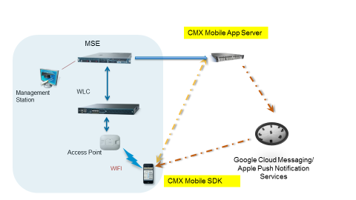

Prime Infrastructure does not require any changes to support CMX Mobile Application SDK

Connect and Engage reside on the same system and require a 8.0 release version.

CMX Mobile App Server is distributed as a Linux RPM.

CMX Mobile Application SDK libraries can be integrated into an existing Android or iOS application.

## CMX Mobile Application SDK Features

### Indoor Location

The CMX Mobile SDK can update an application about the current location of the device. Locations are calculated by the MSE which in turn notifies the CMX Mobile App Server about device location updates. The CMX Mobile SDK enables an application to be indoor location aware with simple APIs and allows the calculation and determination of the location to be handled by the SDK. The location can be a relative X,Y position on a floor map, a GPS location within a building, or a zone defined for a floor.

### Indoor Map View

The CMX Mobile SDK allows an application to embed a map view into the application. The map will display points of interest and has search capabilities for the points. Routing can be done to a point of interest from the current location. The application allows the SDK to manage the user interface for just the map presentation only.

### Wifi Onboarding

The CMX Mobile SDK has the ability to assist a user with joining a desired Wifi. A mobile push notification can be sent from the CMX Mobile App Server when a device is detected or enters a specific zone. The push notification can be used to launch an application and the metadata for the message can contain information on which Wifi to join. The same can also be done when the application is launched and the venue information is accessed for the first time. When attempting to join the Wifi there are several options available on how to join the Wifi. These options are only used when the mobile device has not joined the desired Wifi.

#### Automatic

The automatic option will enable and change the current Wifi settings of the mobile device to the desired Wifi. The user will not have to perform any actions as this will be done automatically when the application is launched. This option is only available for Android devices.

#### Prompt

The prompt option will display a dialog asking the user permission to join the desired Wifi. If the user accepts then the Wifi will be enabled and joined automatically. This option is the same as automatic but the user is asked permission for attempting to join the Wifi. This option is only available for Android devics.

#### Manual

The manual option will display a dialog with instructions on how to join a desired Wifi. The user will have to join the Wifi manually. This option is available for iOS and Android.

# Installation

## CMX Mobile App Server Installation

The CMX Mobile App Server is distributed as an RPM which can be installed on a Linux server. The installation is done by using the RPM install command:

rpm –iv cmx-mobile-app-server-0.1.4._1.x86_64.rpm

This will install the CMX Mobile App Server in **/opt/cmx-mobile-app-server** directory

If the installation is an upgrade then use the RPM upgrade command:

rpm –Uvf cmx-mobile-app-server-0.1.4._1.x86_64.rpm

The setup script is then required to run to configure on a new installation. The required configuration needed is the userid/password for communication with the server.

Run the setup script using the following command:

/opt/cmx-mobile-app-server/setup/setup.sh

Then the following is displayed:

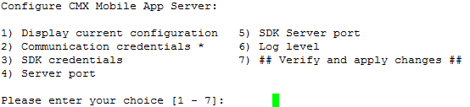

Select option 2 to change the communication credentials

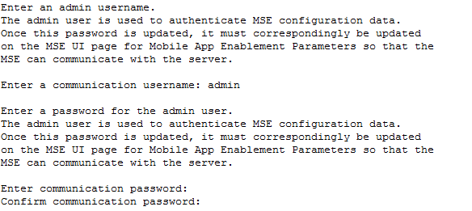

Then to save the changes select option 6.

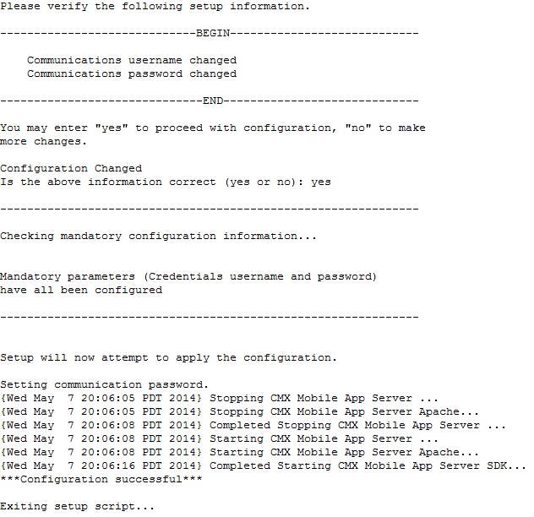

The settings will be applied and the server restarted.

### SDK Credentials

The SDK credentials are required if the CMX Mobile App Server SDK APIs are going to be used. These APIs are designed to be used by administrators or other server applications. A userid and password is required to access these APIs and are set in the setup script.

The steps are the same as setting the server credentials. Choose option 3 if using the menus to set these credentials.

## Prime Infrastructure

After Prime Infrastructure (PI) is running with required licenses and floor maps, add MSE by navigating to **Services->Mobility service**. Synchronize controllers as well as network design to this MSE so that mobile clients can be tracked.

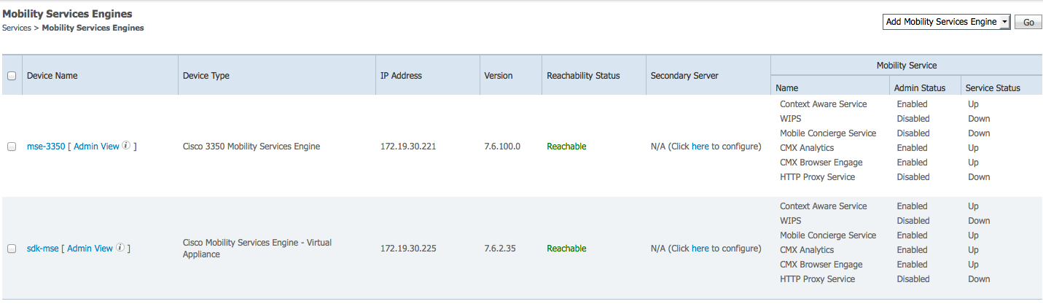

## Mobility Service Engine

After the MSE is running with the proper license. The recommended configuration currently for Beta is to have the Context Aware Service (CAS) and Connect and Engage all running on the same server.

Log in the MSE UI and click on configuration

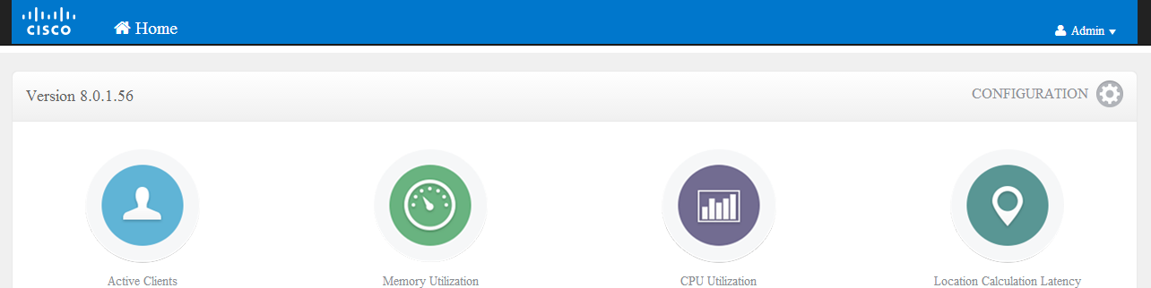

Add the CAS Server from **Settings** and selecting **CONNECT AND ENGAGE -> Setup**. This server will be used to send movement information to the CMX Mobile App Server. Also Connect and Engage will use this server to load venue information. Click the **Add CAS MSE** to add the server

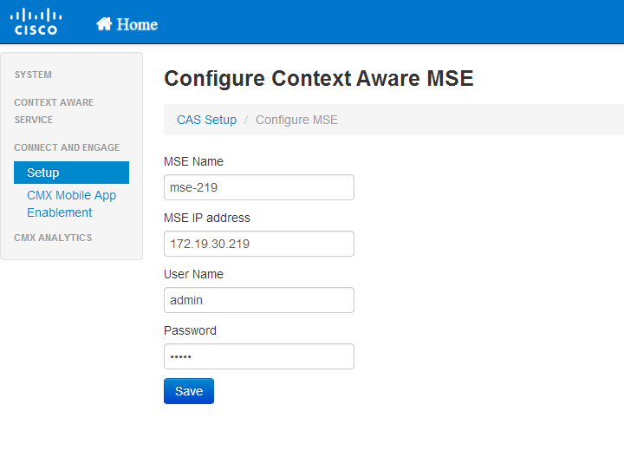

Enter the required attributes and click **Save**.

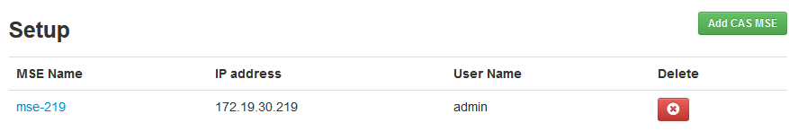

## CMX Mobile App Server Connection

The CMX Mobile App Server and MSE should now be installed. A connection can be established to the CMX Mobile App Server to send configuration data and client movements. This is done from **Configuration** and selecting Connect and Engage -**> Mobile App Enablement**. On the Mobile App Enablement page is a radio button option for **Enable CMX Mobile App Integration**.

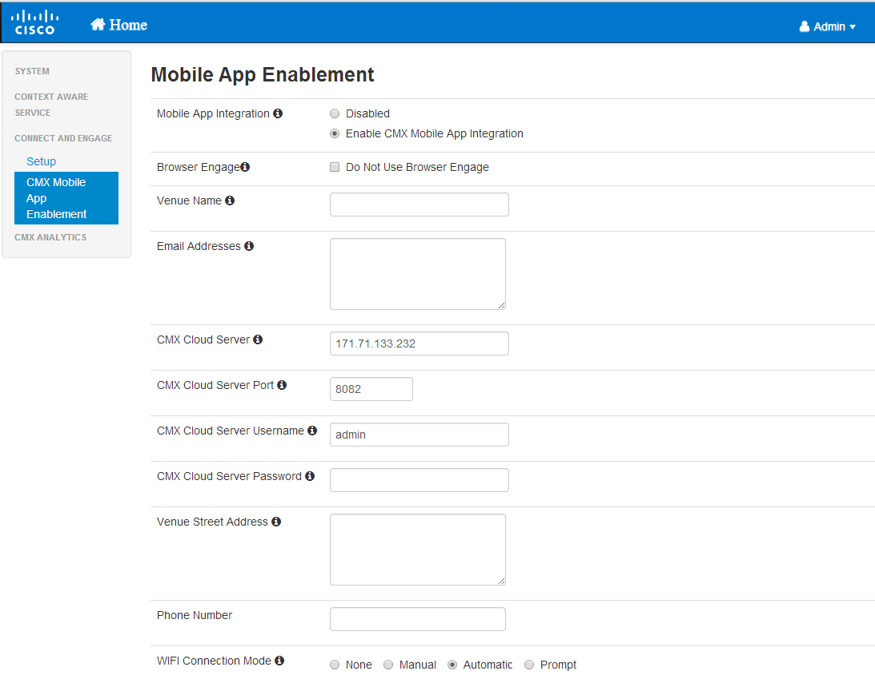

### Do Not Use Browser Engage

This option should be checked only if device tracking is desired. Points of interest, routes, and zones will not used. The maps from Prime Infrastructure will still be uploaded and the position of the device can be tracked by location on map or GPS if GPS markers have been placed.

### Venue Name

This should be a descriptive name for the venue.

### Email Addresses

A list of email addresses separated by commas.

### CMX Mobile App Server

The server IP address should be supplied of the CMX Mobile App Server.

### CMX Mobile App Server Port

The port by default uses 8082. Change if the port was changed on CMX Mobile App Server using the setup script.

### CMX Mobile App Server Username

The username entered on the CMX Mobile App Server during setup.

### CMX Mobile App Server Password

The password entered on the CMX Mobile App Server during setup.

### Venue Street Address

Address for the venue

### Phone Number

Phone number for contact

### Wifi Connection Mode

A device can attempt to join a venues wifi if desired. Manual indicates the user will be given a descriptive instruction on how to join a wifi. The user has the option to follow or ignore the instructions for joing the wifi. Automatic indicates the device will attempt to join automatically if possible. This will only work properly with Android devices. iOS devices will fallback to using manual instructions since the platform does not allow for automatic.

### Preferred Networks

The list of SSIDs to attempt to join with when at the venue. The password is optional.

# Connect and Engage

At this point the installation has been completed successfully. The following are the configuration and status steps to leverage the features of the SDK.

## Configuration

The remaining features can be configured in Connect and Engage. Connect and Engage can be access by first entering the MSE UI: https://<MSEAddress>/mseui/

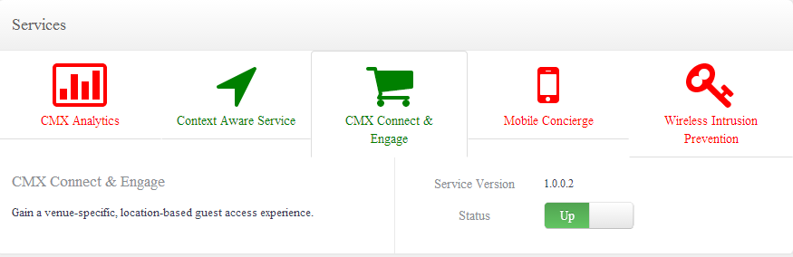

On the dashboard select **CMX Connect & Engage under the Services section. Once the Status is up the CMX Connect and Engage App under the Apps section will appear.**

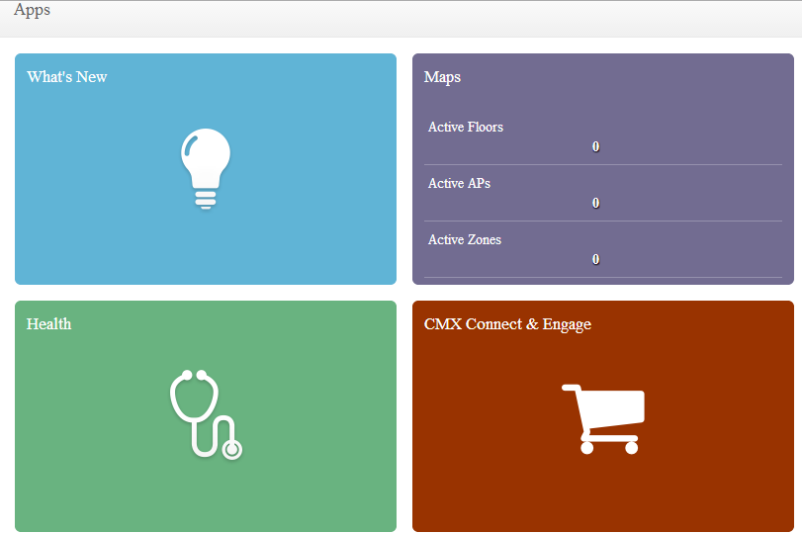

Selecting the CMX Connect & Engage App will open the App and a Login dialog will appear.

Once Logged in you will see the Mobile App option on the left side. Once that option is selected all configuration and status buttons options appear under Mobile App

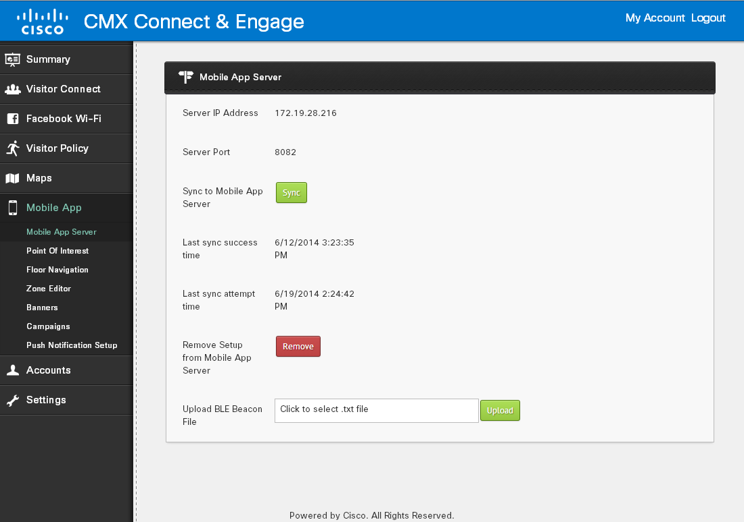

### Mobile App Server

To view rudimentary statistics like App Server IP Address, Server Port, last sync success and last sync attempt times. The last sync success time is the time when the Mobile App Server was last successfully synchronized. The last sync attempt time is the time when a last sync to Mobile App Server was attempted.

The Sync button forces all the configuration to be synchronized to the Mobile App Server. The Remove button removes all the configuration from the Mobile App Server. Once the configuration is removed, the Mobile App Server will need to be reconfigured via the Connect and Engage, App Enablement page.

### Point Of Interest

The Point of Interest page contains options to create new Point Of Interests, Edit existing point of Interest and delete existing Point Of Interests. There is an option to make the Point Of Interest Inactive as well.

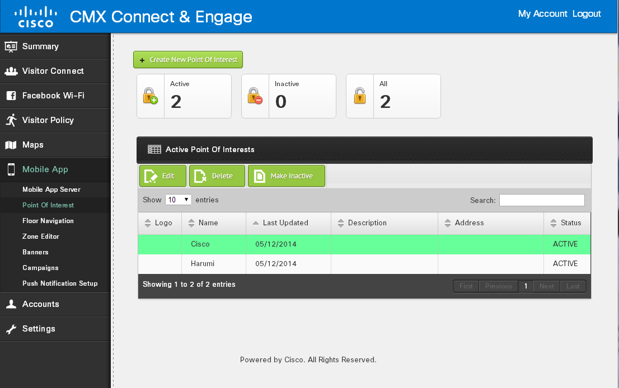

To create a new Point Of Interest select the create new point of interest button which will open a page where all the required and optional parameters will be present in order to create a point of interest.

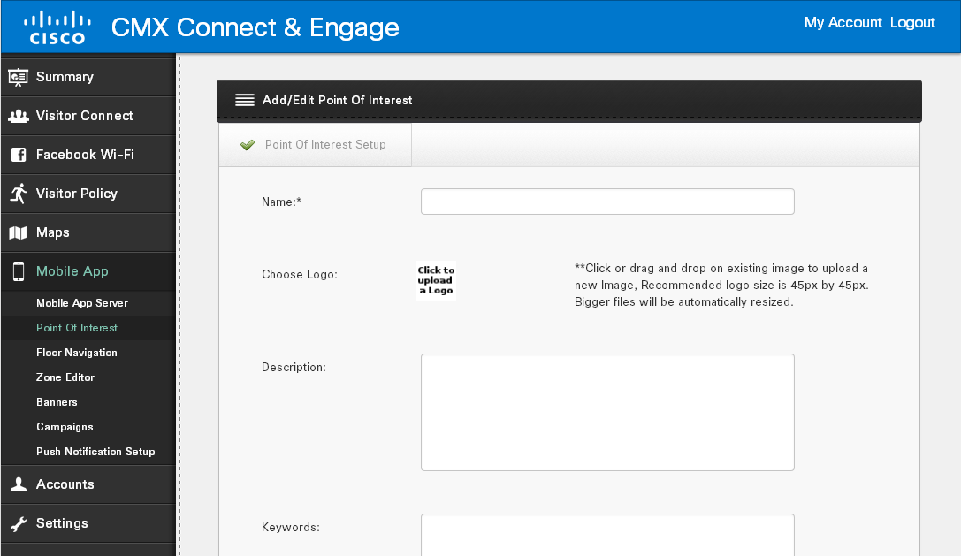

Once a new Point Of Interest is created the Point Of Interest has to be made active. Clicking on the Inactive button will list out all the Point Of Interests that are inactive. To make a Point Of Interest active click on any Point of Interest and make it active.

### Floor Navigation

### Routes

Routes need to be configured on the map to allow for navigation to a point. The route is used to navigate the user to the desired destintation. The routes are created by drawing lines on the map. To start creating a route select the **Floor Navigation** folder. Then select the desired floor to add routes.

To start creating a route click on the **Draw Point** icon. Place the point on the map. Then repeat this by placing points at different spots on the map. These points will be used to connect the route lines.

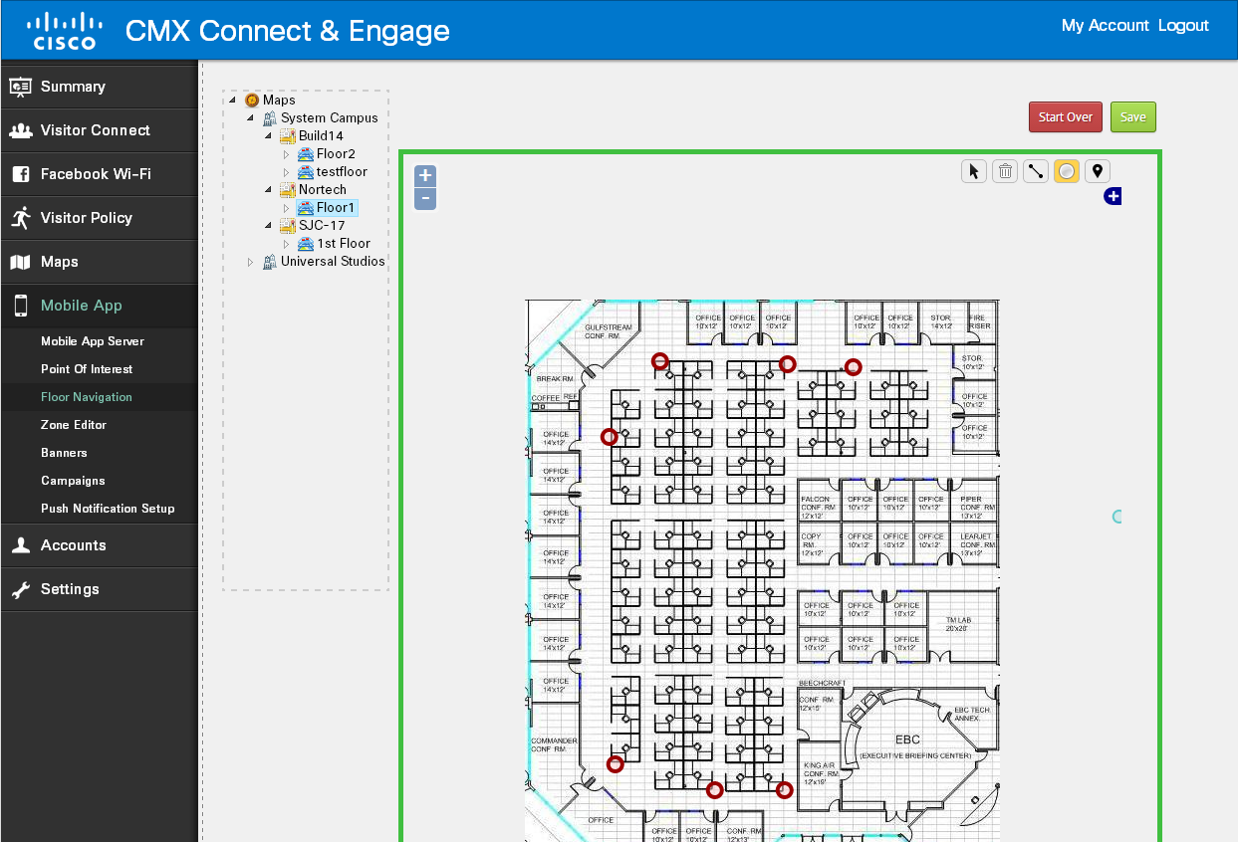

To start connecting the lines click on the **Draw Lines** icon. Click on a point to start and another point to join the line. Repeat this as needed.

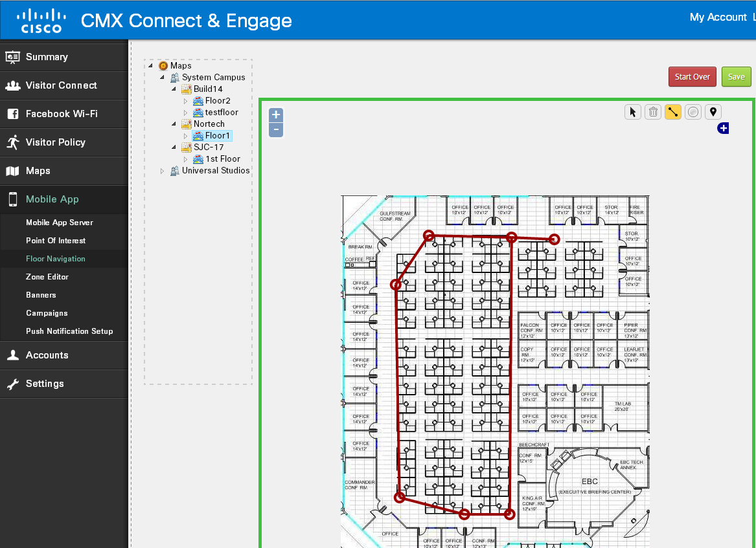

When ready click the **Save** button to save the information.

### Points Of Interest

To add a point of interest click on the **Plot POI icon**. Then click on the position on the map to place the point of interest. To edit the point of interest details, click on the **More Info** icon. Then click on the point of interest to edit. The Point of Interest should be assigned a configured Point Of Interest.

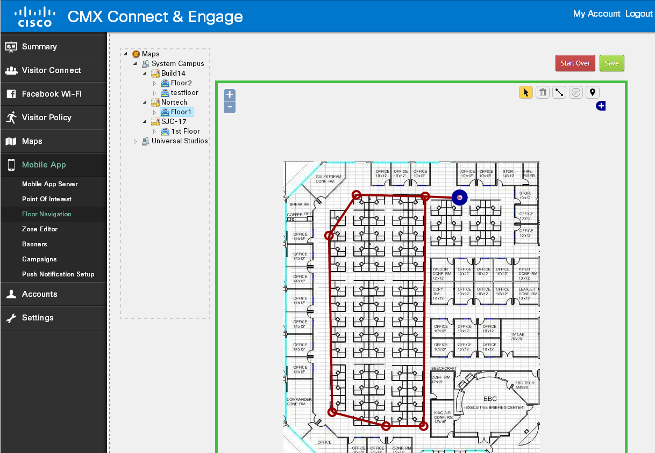

Now, configure Banners and Campaigns by selecting appropriate menu items on LHS pane

### Zone Editor

In the Zone Editor folder is a way to view the maps used in PI. If the maps are not showing any campus or building information. Then click on the Update Maps from PI button. This will import the maps and overwrite any existing maps.

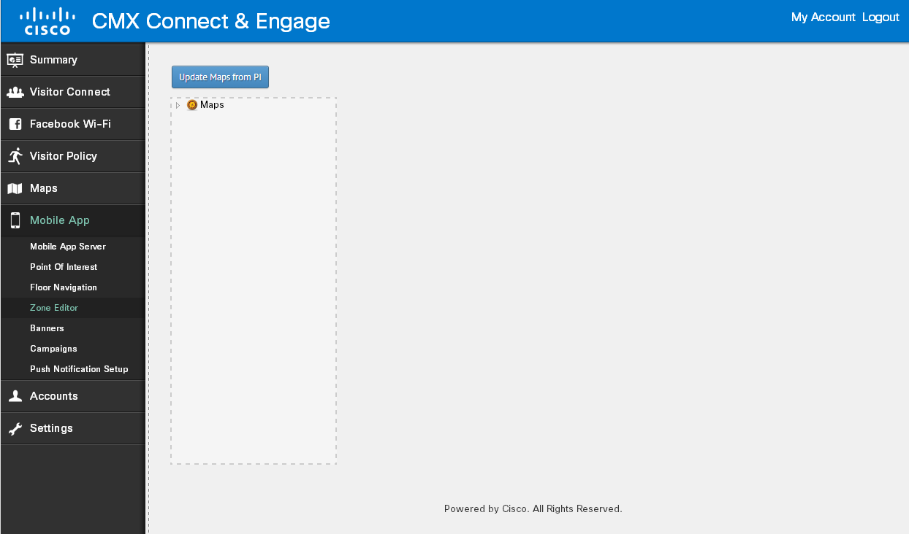

Once imported successfully the campus, building and floor tree information should be displayed.

### Zone Configuration

Zones can be configured on the map to do mobile push notification to the device. The zone can also be used in the mobile SDK for banners or other functionality the application may want to implement.

To draw the zone click on the **Draw Polygon** icon to start creating a new zone. Left click on map to start creating the zone. Double left click to complete the zone.

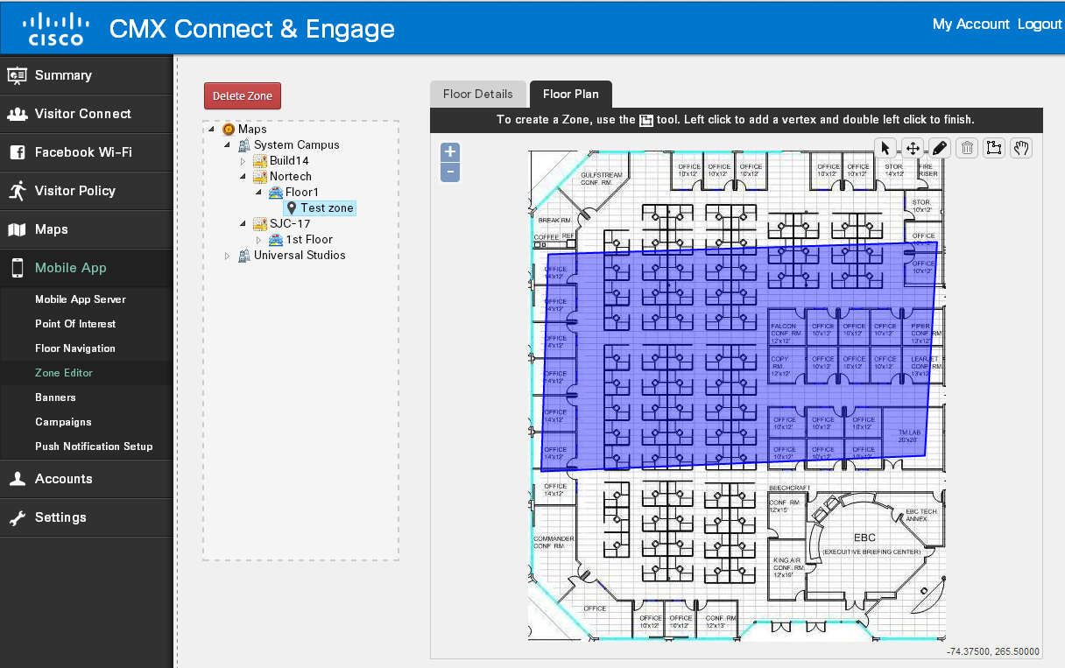

The zone can be given a name and a description. Make sure you click the **Submit** button to save the zone on the map.

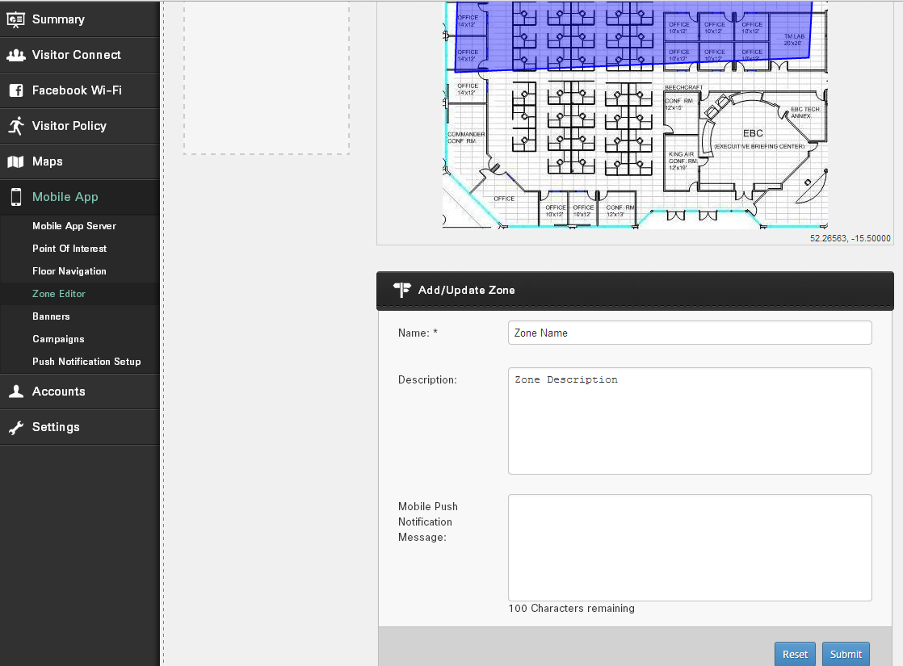

### Banners

The Banner page contains options to create new Banner, Edit and delete existing Banners. There is an option to make the Banners Inactive aswell.



To create a new Banner select the create new banner button which will open a page where all the required and optional parameters will be present in order to create a banner.

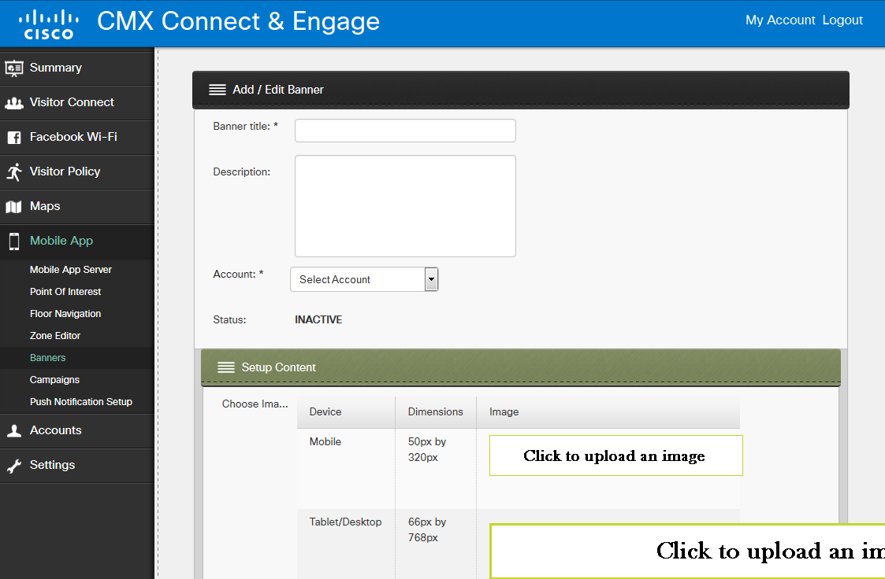

### Once a new Banner is created the banner has to be made active. Clicking on the Inactive button will list out all the Banners that are inactive. To make a Banner active click on any Banner and make it active. Campaigns

Zones and Banners are tied together by campaigns. The Campaign page contains options to create a new Campaign, Edit and delete existing Campaigns. There is an option to make the Campaigns Inactive aswell.

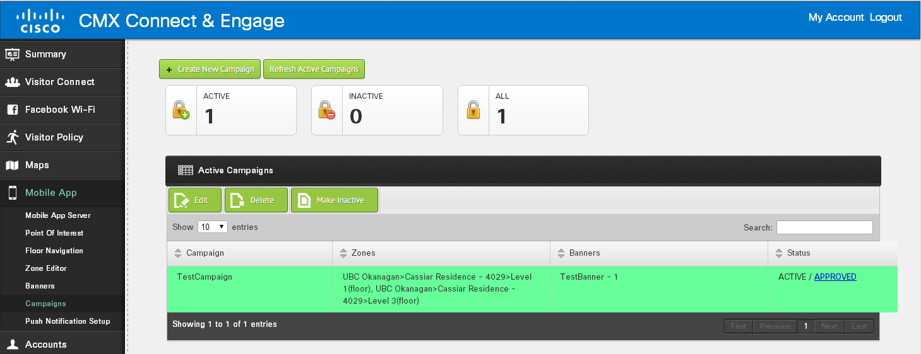

Once a new Campaign is created the campaign has to be made active. Clicking on the Inactive button will list out all the Campaigns that are inactive. To make a Campaign active click on any Campaign and make it active.

To create a new Camaign select the create new campaign button which will open a page where all the required and optional parameters will be present in order to create a campaign. Campaign should be assigned to a Point Of Interest. Zones should be selected to which this campaign should be applied to and banners should be added to the campaign. Multiple zones and banners can be added which means that the banners apply to the zones specified for a particular campaign.

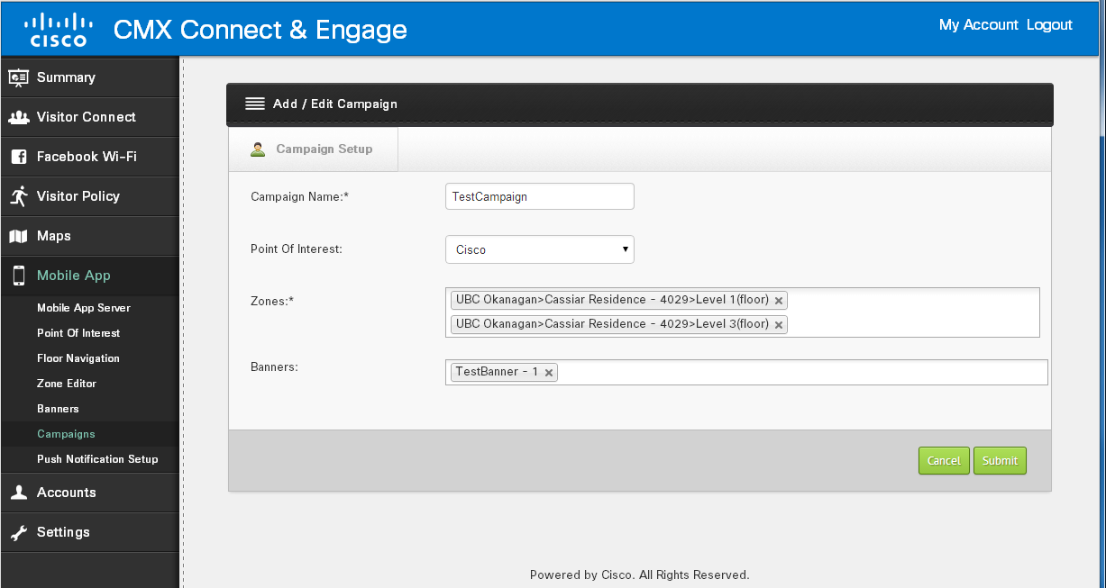

### Mobile Push Notifications

Mobile menu item is place to set push notifaction keys for CMX Mobile App Server which will be used to send push notifications. To send push notification for Apple devices, user require .p12 file and password from Apple developer web site, while for android applications user need to get sender id and API key from google play developer console web site. Sender id will used in mobile application wihle API key will use server side. For Apple there is an option to configure the Mobile App Server to use the Sandbox server or Production server for push notification and this applies to Apple only.

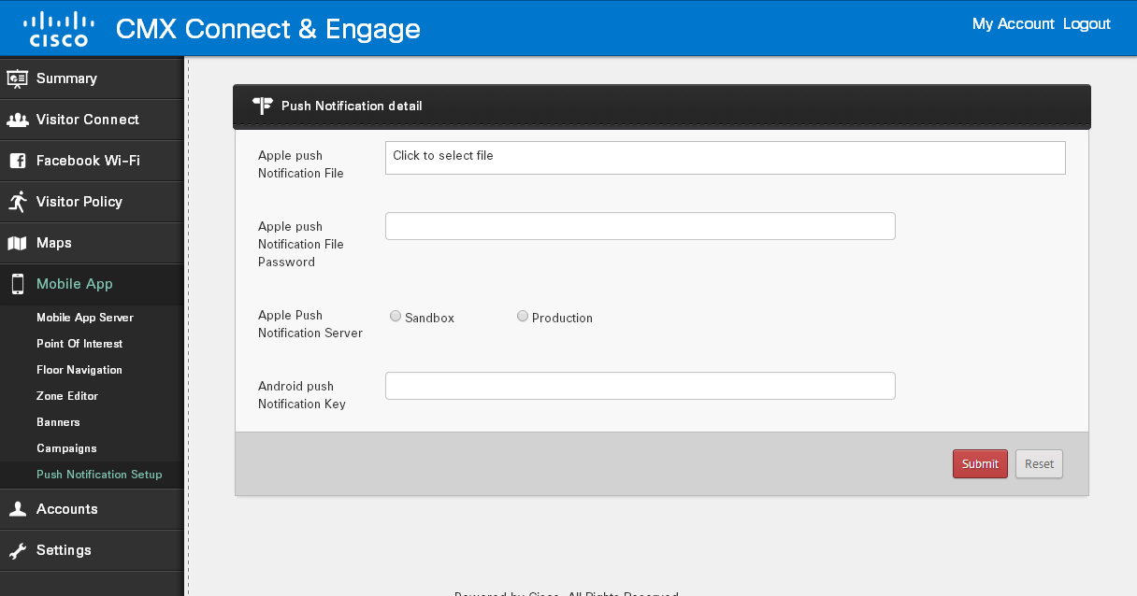

### BLE Beacon Configuration

Cisco MSE and Cisco CMX SDK together support BLE beacon configuration on MSE 8.0 and later and CMX iOS SDK versions 1.0.0 and later. This feature at present is available only on Apple iOS devices which support Bluetooth (iOS 7 and above on iPhone 4s and above, iPad Minis and iPad 3rd Generation or later) and has BLE turned on.

Using BLE beacons at present the CMX SDK can:

1. Enable an application developer to download the list of BLE beacons placed on a floor or at a venue. The application developer can then decide how to make use of the BLE information.
2. Start monitoring for particular regions (upto 20) and present a local notification with a message to a user when the region is detected on an iDevice.
3. Update the location of the user when the proximity of the user to the beacon falls within a certain RSSI which indicates presence next to the beacon. The location of the user is then updated to the location of the beacon and the zone of the user is updated to the zone of the beacon.

### Configuration

The configuration for BLE Beacons can at present be done on MSE Connect and Engage. Launch the MSEUI Page (http://<mseip>/mseui/) and go to the Connect and Engage app. The default login is admin/admin. On the Connect and Engage Page browse to Mobile App > Mobile App Server.



Now under Upload BLE Beacon File the user can upload a file in .txt format which contains a BLE beacon list populated with the following fields in JSON format:

{

"uuid": "A77A1B68-49A7-4DBF-914C-760D07FBB87B",

"major": “1”,

"minor": “1”,

"mfgId": "1111",

"calRssi": "12",

"floorId": "-6047452740341202830",

"xCord": “100”,

"yCord": “100”,

"zCord": “0”,

"bleBeaconName": “iPadTestBeacon”,

"bleBeaconType": "1",

“regionIdentifier”: “com.cisco”,

"message": "Welcome to beacon zone”

}

Once this information is uploaded, sync to the CMX Mobile App Server.

Using the region Identifier listed on the JSON, CMX SDK on the client’s application starts monitoring for BLE Beacons and throws a local notification with the message listed when the region is first detected or entered.

It then starts ranging beacons within the region and when it is in close proximity to any beacon having a listed UUID within the region, it updates the client position to the x and y coordinates of the beacon.

## Status

### CXM Mobile App Sync Status

The CMX Mobile App Server status can be viewed on the **CMX Mobile > Mobile App Sync** Status page.

The page also allows for a sync to be initiated. By depressing the Sync button the current configuration will be pushed to the CMX Mobile App Server.

The remove button allows for the configuration data to be removed from the server.

# CMX Mobile App Server

### Starting Server

Starting the server can be done by running the command **/etc/init.d/cmx-mobile-app-server** script:

#/etc/init.d/cmx-mobile-app-server start

### Stopping Server

Stopping the server can be done by running the command **/etc/init.d/cmx-mobile-app-server** script:

#/etc/init.d/cmx-mobile-app-server stop

### Status Of Server

Status of the server can be done by running the command **/etc/init.d/cmx-mobile-app-server** script:

#/etc/init.d/cmx-mobile-app-server status

### Backup/Restore

All files needing a backup are located in **/opt/cmx-mobile-app-server/data** directory. Just tar this directory periodically.

On restore just stop the server and untar the directory. On startup the data will be restored.

### Debug Collection

If any issue needs to be reported then run the script **/opt/cmx-mobile-app-server/bin/collectDebugInfo.sh**. This will collect all needed logs and debug information and bundle them into the file **/opt/cmx-mobile-app-server/logs/cmx-debug-logs.tar.gz**.

### Server Configuration

The current server configuration details can be viewed by running the script **/opt/cmx-mobile-app-server/bin/getServerConfig.sh**. This will display venue configuration information defined in Connect and Engage.

### Server Stats

The current server statistics can be viewed by running the script **/opt/cmx-mobile-app-server/bin/getServerStats.sh**. This will display statistics about Context Aware Service notifications, Mobile SDK requests, Mobile push notifications and Connect & Engage configuration statistics.

### Debug Commands

The server has a few debug commands to assist with troubleshooting problems. The commands are located in the **/opt/cmx-mobile-app-server/bin** directory.

### Get Location By MAC Address

The current location the server has for a client can be displayed by MAC address running the command:

**/op/cmx-mobile-app-server/bin/getLocationByMac.sh *<macAddress>***

* ***<macAddress>*** is the client MAC address to display the current location for

### Monitor Location By MAC Address

The current location the server has for a client can be monitored by MAC address running. The command will continually run unitl <CTRL+C> is used to stop the monitoring. The command will update the terminal with the latest location as it is updated on the server. The command syntax is:

**/op/cmx-mobile-app-server/bin/monitorLocationByMac.sh *<macAddress>***

* ***<macAddress>*** is the client MAC address to display the current location for

### Send Push Notification Message

A push notification can be sent to a client based upon the MAC Address. This can be used to validate the client can receive push notifications initiated by the server. The command syntax is:

**/op/cmx-mobile-app-server/bin/sendPushNotificationByMac.sh *<macAddress> “<message>”***

* ***<macAddress>*** is the client MAC address to send the mobile push notification to
* ***“<message>”*** is the message to be sent to the client

### Test Push Notification Message

A push notification can be sent to a client based upon the MAC Address. This can be used to validate the client can receive push notifications initiated by the server. This command has additional ouput information and directly invokes the sending of the push notification. The command syntax is:

**/op/cmx-mobile-app-server/bin/testPushNotificationByMac.sh *<macAddress>***

* ***<macAddress>*** is the client MAC address to send the mobile push notification to

# CMX Mobile App Server SDK

The CMX Mobile App Server has a REST API which can be used by administrators or other server applications. The REST API should not be used for public use as some of the APIs can be used to obtain location information about other devices. By default the REST APIs run on a different port then the public access interfaces used by mobile applications. The default port is 8085.

### Client location by MAC Address

**/cmx-mobile-app-server-sdk/api/cmxmobileserver/v1/clients/location/{macAddress}**

Method: **GET**

Returns the location of a wireless client based upon the MAC Address.

Accepts

* Application/json

Response

{

"macAddress": "34:c8:03:8d:45:c8",

"lastLocationUpdateTime": 1394742659768,

"venueId": "",

"floorId": "-6047458182064766816",

"mapCoordinate": {

"x": 133.5067,

"y": 77.57402

}

}

# CMX Mobile Application SDK

The CMX Mobile Application SDK provides indoor location, navigation and can join a specified Wifi connection using a mobile push notification. The SDK is composed of several modules to allow for varying types of application integration. The CMXClient is the core module for getting client and venue information. The module has no UI and can be embedded into an application to determine current location information for the application to take action upon. The CMX Map module allows for a map view to be integrated into an application. The map view will render a map with points of interest. A user’s current location will be displayed on the map and the user has the ability to select a point of interest to navigate to.

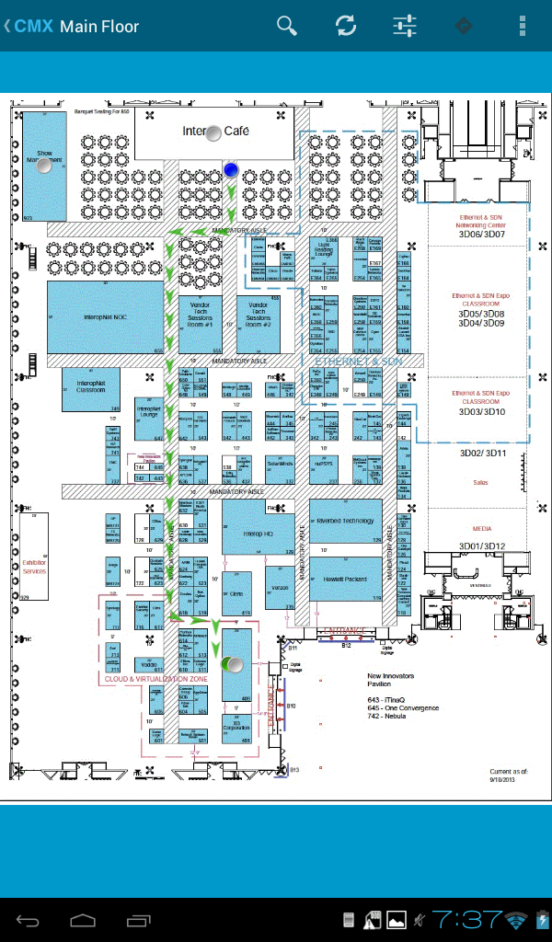

# CMX Mobile Application SDK for Google Android

## Getting Started

Before you can begin working with APIs, you need to download the SDK and supportive libraries from specified location, which include CMX sdk, appcompat, google-play-services_lib and SlidingMenu libraries.

## Overview

Creating new application using CMX SDK is require several steps. Overall process of using sdk into application is as follows

• Import libraries into workspace and set dependencies.

• Create new application and add dependency of CMX sdk.

• Add permissions and required settings into application’s manifest file.

• Add map into application.

• Publish application.

## Requirement

Devices (Smartphone and Tablets) with minimum android version of 2.3 and higher will support this SDK.

## Configure Library

Download, unzip and import libraries as android projects into a workspace. Configure dependencies for each library projects

• Add library dependency of android-support-v7-appcompat, google-play-services-lib and SlidingMenu into CMX by project properties > android > add.

• Add library dependency of android-support-v7-appcompat into SlidingMenu library.

## Permissions

CMX sdk using device features like Wi-Fi, GPS, push notification, network access to provide a great experience for users so application require these permissions in manifest file

• Android.permission.INTERNET

• Android.permission.ACCESS_WIFI_STATE

• Android.permission.ACCESS_NETWORK_STATE

• Android.permission.CHANGE_WIFI_STATE

• Android.permission.ACCESS_FINE_LOCATION

• Android.permission.ACCESS_COARSE_LOCATION

• Android.permission.GET_ACCOUNTS

• Android.permission.WALE_LOCK

• Com.google.android.c2dm.permission.RECEIVE

With permissions, application require device feature also in manifest file

• Android.hardware.wifi

SDK supports push notification, and if application wants to use push notification feature, first it needs to create a custom permission using application package name with protection level “signature” like

<permission android:name=”application package name.permission.C2D_MESSAGE” android:protectionLevel=”signature”/>

**Example:**

<permission android:name=”com.cisco.cmx.app.permission.C2D_MESSAGE” android:protectionLevel=”signature”/>

Once permission created, add in permission list.

**Example:**

<uses-permission android:name=”com.cisco.cmx.app.permission.C2D_MESSAGE” />

## Getting ready to access APIs

To use this SDK and access APIs, first initialize using singleton class CMXClient from SDK.

**Example:**

CMXClient.getInstance().initialize(context);

Now SDK is ready to make user requests.

Application settings like “Enable push notification”, “Location refresh interval” can be configuring using Configuration class provided in CMXClient.

## Registration

Registration is the first step to connect with server and get device unique id which use for location request. Registration is performed using registerClinet() method of CMXClient class.

**Example:**

CMXClient.getInstance().registerClinet(new CMXClientRegisteringResponsehandler() {

@Override

Public void onSuccess() {

Super.onSuccess();

//TODO: start communication with server, load venue information

}

@Override

Public void onFailure() {

//TODO: Display failed message and end application

}

});

## Location

Location is a periodic update from SDK by using startUserLocationUpdate method of CMXClient class. Application needs to be registered with CMX Mobile App Server in order to use location feature.

Default update interval can be updated using settings, and handler is responsible to handle periodic updates from SDK.

To stop location updates, application need to stop periodic updates using stopUserLocationPolling method.

**Example:**

Local broadcast is a way to broadcast location updates in application.

CMXClient.getInstance().startUserLocationUpdate(updateinterval, new CMXClientLocationResponseHandler(){

@Override

public void onUpdate(CMXClientLocation location) {

Intent intent = new Intent(USER_LOCATION_UPDATE_ACTION);

Intent.putExtra(USER_LOCATION, location);

LocalBroadcastManager.getInstance(context).sendBroadcast(intent);

}

});

Developer needs to write their own broadcast receiver to handle this broadcast for location update.

## Getting Venue Information

System information include venues, floors per venue, point of interests per floor, zones per floor, maps information, images for point of interest, maps, venue. CMXClient class has methods to provide these details. System information is structured in ordered way so follow these steps

1. Load venues info using CMXClient.getInstance().loadVenues(CMXVenueResponseHandler)

This will return list of venues with venue network infomraiton.

2. Load floor and map image information using CMXClient.getInstance().loadFloor(venueId, CMXMapResponseHandler)

3. Now you can load point of interests by using venue and floor information in step 1 and 2. Use CMXClient.getInstance().loadPois(venueId, floorid, CMXPoisResponseHandler) to load pois.

4. Once venue and floor information is available, use loadFloorImage() method to get floor map.

## Map View

CMX SDK provides map view which can be added into any application. This map view handles downloading of floor maps, location updates. This map view is CMXMapActivity which can be start from any activity. User need to provide list of venues, floors and pois to this view. To start Map view

1. Load list of venues
2. Load floors for each venue
3. Load pois for each floor in each venue

Now start CMXMapAcitvity to load map view by

Intent intent = new Intent(context, CMXMapActivity.class);

i.putParcelableArrayListExtra(“VENUES”, venuelist);

i.putParcelableArrayListExtra(“MAPS”, floorlist);

i.putParcelableArrayListExtra(“POIS”, poilist);

startActivity(intent);

where venuelist, floorlist and poilist are list of venues, floors and pois.

You need to use Theme.AppCompat.Light.DarkActionBar style for resources in application.

Below is the UI for map view.

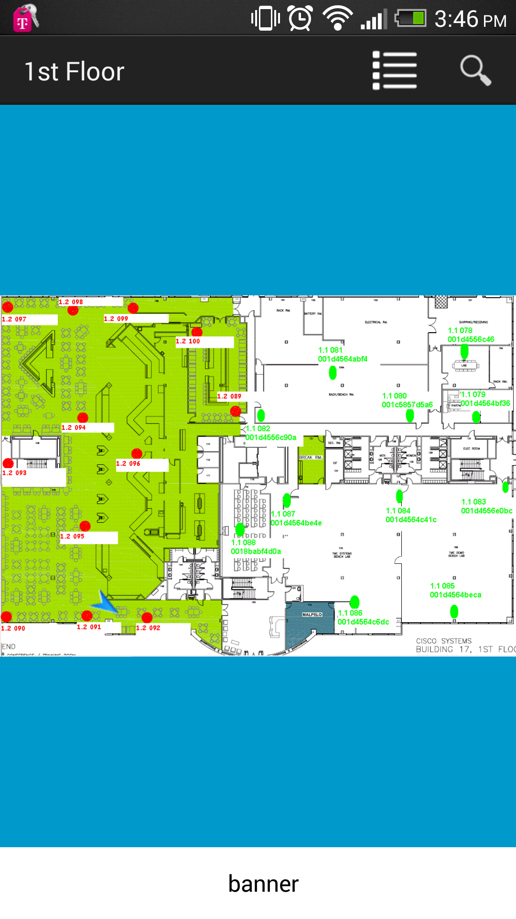

## Push Notification

User can use this fature to send any notification from CMX Mobile App Server. To use this feature use need to generate sender id and server API key using google console. API key will be used at server side while sender id will be used in android application. Registration process requires this sender id to get push notification id from Google and register with CMX Mobile App Server.

# CMX SDK Android sample application

### Overview

This sample application give user an overview of SDK APIs, This application has main screen which shows basic informations using SDK APIs. First time, when application is not registered, it will try to register at default Server. User need to change the server URL from settings screen and restart application.

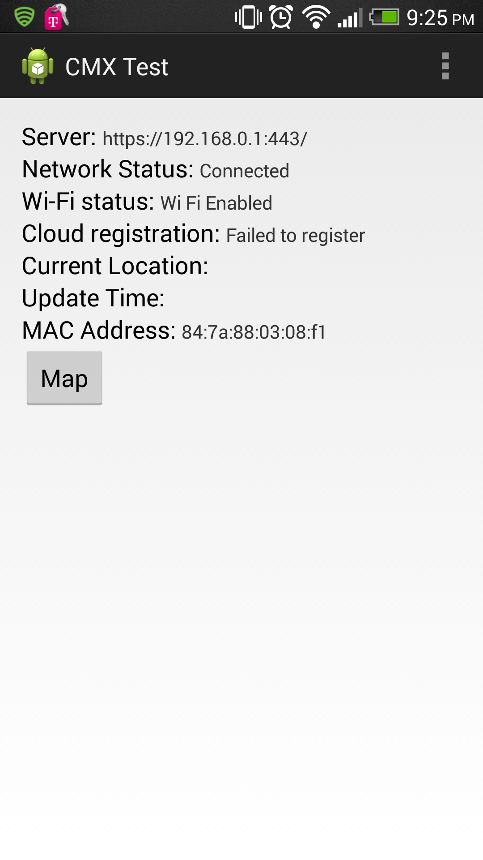

Once application is registered, and user started getting location updates, screen show like

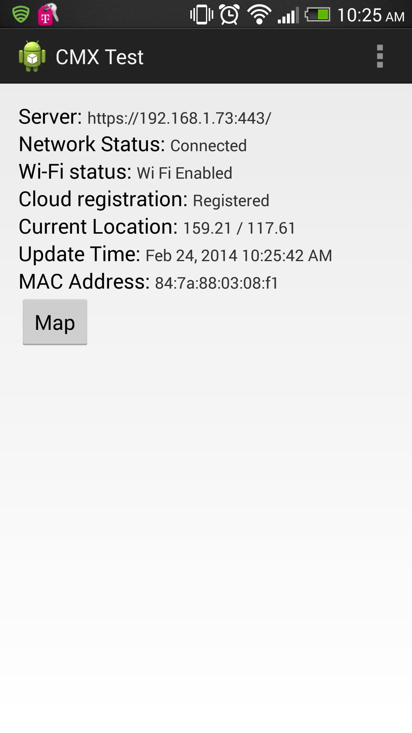

Map view is another feature which give indoor maps with blue dots. Map button will move user to map view.

### Getting started

This document assume that developer downloaded CMX SDK and supported libraries

And imported these in eclipse project workspace. These supported libraries are

Androi-support-v7-appcompat, google-play-services_lib, SlidingMenu, FacebookSDK.

These are the steps which need to folllow to create application using CMX SDK

1. Imports libraries into workspace
2. Set dependencies
3. Create new application
4. Import CMX SDK as library into application.
5. Set required permissoins.
6. Initialize SDK by providing application context and sserver address
7. Register application with server by using SDK API.
8. Call locaiton SDK’s location API to get location.

### Setup

Import all CMX SDK, and all supported librarie into workspace and set dependencies

Add library dependency of android-support-v7-appcompat, google-play-services-lib, FacebookSDK and SlidingMenu into CMX by project properties > android > add.

Add library dependency of android-support-v7-appcompat into SlidingMenu library.

8.2.2 New Application

Create a new android application project in eclise and import CMX SDK as library in that project by

Right click project > properties > android > add.

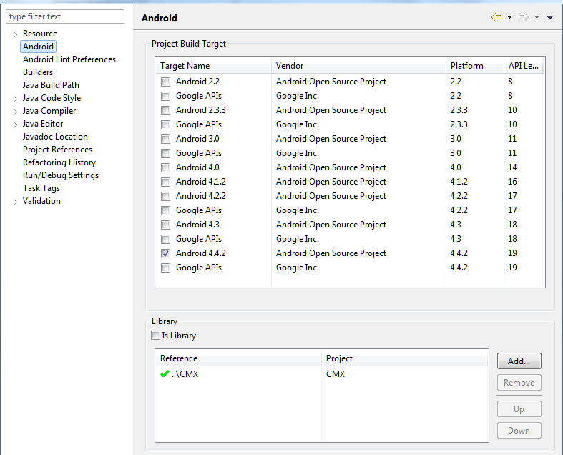

This way SDK is referenced into application.

Adnroid support any feature by adding permission in AndroidManifest.xml file, so add

<uses-permission android:name=*"android.permission.INTERNET"*/>

<uses-permission android:name=*"android.permission.ACCESS_WIFI_STATE"* />

<uses-permission android:name=*"android.permission.ACCESS_NETWORK_STATE"* />

<uses-permission android:name=*"android.permission.CHANGE_WIFI_STATE"* />

<uses-permission android:name=*"android.permission.GET_ACCOUNTS"*/>

<uses-permission android:name=*"com.google.android.c2dm.permission.RECEIVE"* />

<!-- GPS -->

<uses-permission android:name=*"android.permission.ACCESS_FINE_LOCATION"*></uses-permission>

<uses-permission android:name=*"android.permission.ACCESS_COARSE_LOCATION"*></uses-permission>

<uses-feature android:name=*"android.hardware.wifi"* />

Initialize SDK from application by providing application context and configuration. Configuration is used to set server address and sender id for push notification. Server address and sender id can se set into Strings.xml file or directly supply to configuration.

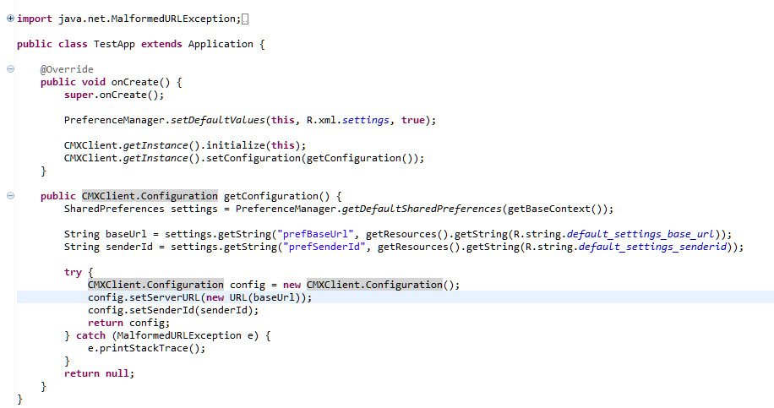

Now SDK is ready to use. Location is the primary feature of the SDk, so to get location, user needs to register with server first. Once registered with server, application can use SDK location API to get location update. This location update is periodic update, so user need to handle this update from application side.

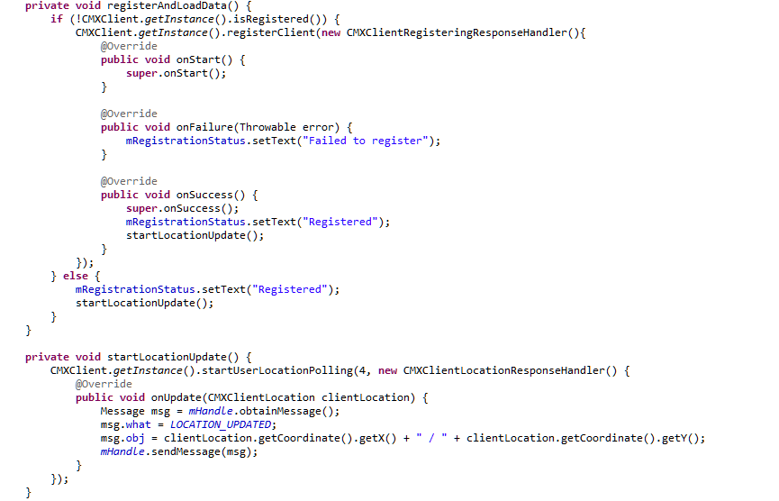

Map view is another feature of this SDK. Map view provides map with blue dot. In SDk, map view is represented by CMXMapActivity class. User need to provide a list of venues, floors for all venues and point of interests for each floors to this activity to start. To start this activity, follow these steps

1. Load all venues
2. Load all floors for all venues
3. Load all pois for all floors.
4. Start CMXMapActivity by using these venues information.

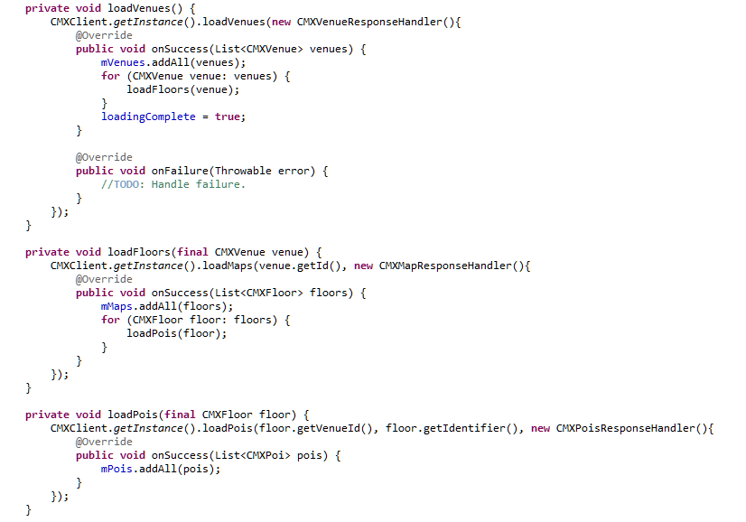

Start CMXMapActivity using

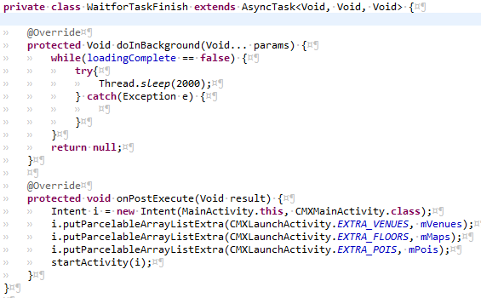

# CMX Mobile Application SDK for Apple iOS

## Overview

Creating new applications using CMX SDK can be summarized in a few steps:

• Download the CMX SDK

• Configure your XCode Project and Dependencies

• Get started

## Requirement

Devices (iPhones and iPads) with minimum ios version of iOS 6.x and higher will support this SDK.

## Download SDK

Download the CMX SDK and add it to your iOS project.

## Installing the SDK

Installation is done by extracting the archive file CmxIosSdk.zip.

After the extraction has completed, you will have the following directories:

CMX Application (using SDK v0.8.1).xctemplate

com.cisco.documentation.Cisco-CMX-SDK-v0.8.1.docset

## Installing the documentation

Copy com.cisco.documentation.Cisco-CMX-SDK-v0.8.1.docset to

~/Library/Developer/Shared/Documentation/DocSets

## Installing the template

Create the folder: ~/Library/Developer/XCode/Templates/CMX

Copy CMX Application (using SDK v0.8.1).xctemplate to

~/Library/Developer/XCode/Templates/CMX

## Creating a new application

Using XCode 5, create a new project (**File > New > Project…**), choose the **CMX Application** template and then press **Next**.

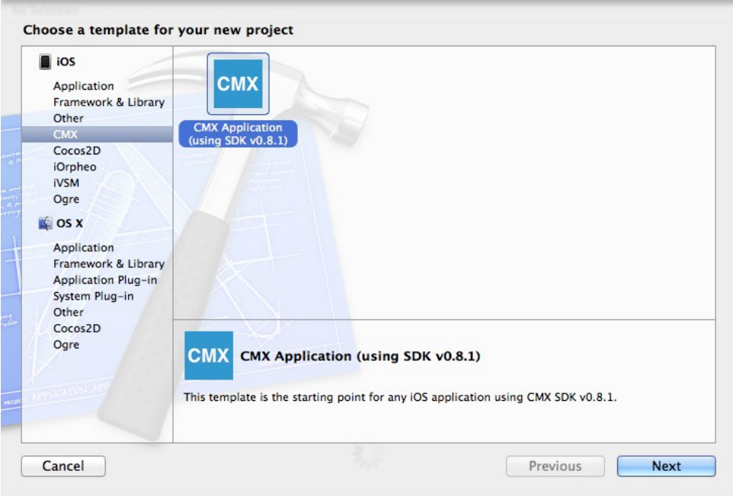

Fill the form with your own information

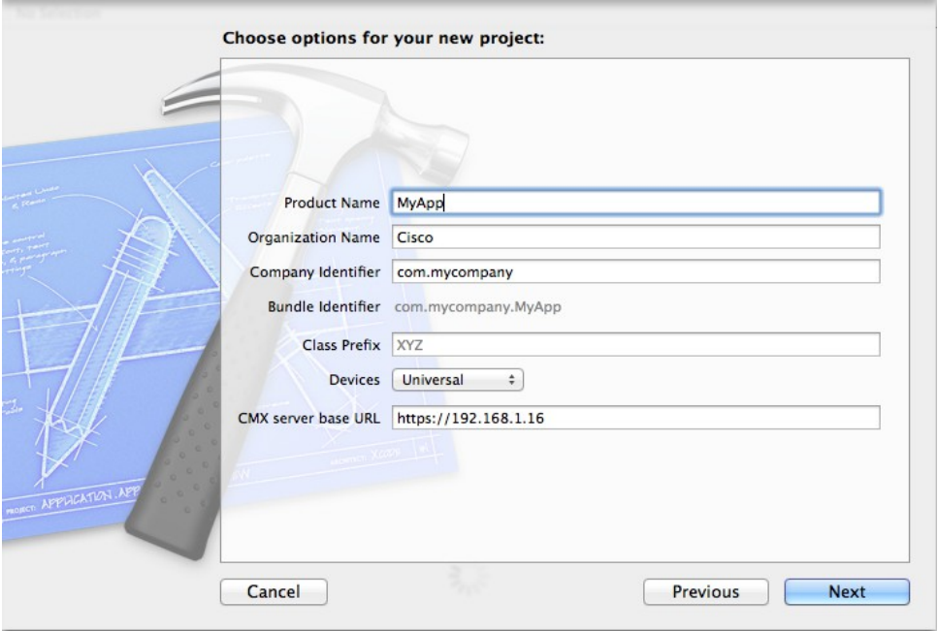

Then create the project. You will get the following:

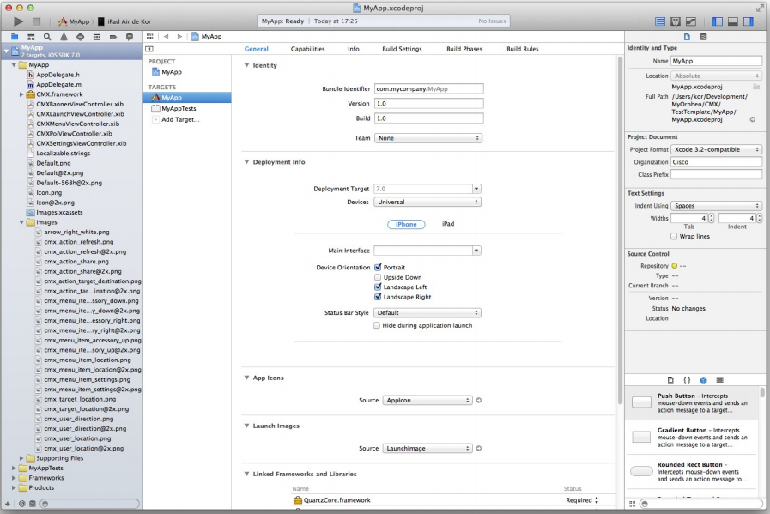

Modify **AppDelegate.m** line: #define kServerBaseURL @”https://”

to the CMX Mobile Server address. For example if the server is running local for testing:

#define kServerBaseURL @”https://127.0.0.1:8082”

Select your target device, then build the project (**Product > Build**).

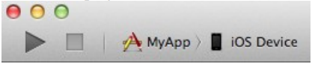

## Configure XCode Project

The CMX SDK provides a framework that you need to add to your XCode project

Open CMX SDK and drag the CMX.framework folder into your Project Navigator. Choose 'Create groups for any added folders' and deselect 'Copy items into destination group's folder '. This will reference the downloaded framework instead of copying it into your project.

## Dependencies

The basic Foundation and UIKit Frameworks are needed by the SDK.

## Getting ready to access APIs

To use this SDK and access APIs, first initialize the CMXClient instance and then configure it with application settings. Now the SDK is ready to make user requests.

**Example:**

[CMXClient instance].configuration = configuration;

Application settings like “Enable push notification”, “Location refresh interval” can be configured using messages provided in CMXClient .

## Registration

Registration is the first step to connect with the SDK server and get a unique id which is used for location request. Registration is performed using registerDeviceToken method of CMXClient.

For iOS registration depending on the iOS versions the following parameters need to be passed for device token registration :

|  |  |  |
| --- | --- | --- |
| REGISTRATION PARAMETERS | IOS6 | IOS7+ |
| **Form parameters :**  clientMACAddress  clientType=ios6  **Optional form parameters :**   pushNotificationRegistrationId | **Form parameters :**   apMACAddress  clientIPAddress  clientType=ios  **Optional form parameters :**  pushNotificationRegistrationId |

**Example:**

if (IS_IOS_7_OR_LATER) {

NSString* macAddress = [self macAddress];

NSString* ipAddress = [self ipAddress];

NSString* apMacAddress = [self accessPointMacAddress];

[params setObject:ipAddress forKey:@"clientIPAddress"];

[params setObject:apMacAddress forKey:@"apMACAddress"];

[params setObject:@"ios" forKey:@"clientType"];

} else {

NSString* macAddress = [self macAddress];

[params setObject:macAddress forKey:@"clientMACAddress"];

[params setObject:@"ios6" forKey:@"clientType"];

}

## Location

Location is a periodic update from SDK by using startUserLocationPollingWithInterval message of CMXClient class. Application needs to be registered with CMX Mobile App Server in order to use location feature.

To stop location updates, application need to stop periodic updates using stopUserLocationPolling mesage.

## Getting system Information

System information include venues, floor per venue, point of interests per floor, zones per floor, maps information, images for point of interest, maps. CMXClient has messages to provide these details.

# CMX SDK iOS Sample App Development

### Application Overview

In this tutorial we are going to develop a sample iOS Application using the APIs provided by CISCO CMX SDK.

The application will have 2 screens:

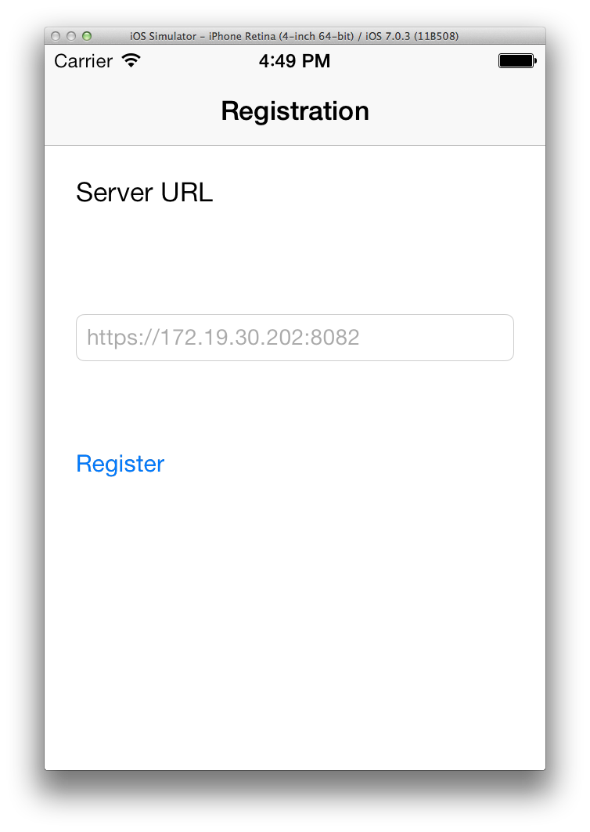

In the first screen we are going to have a Registration screen where you can type in the CMX Mobile App Server URL and hit enter. This will register the client to the CMX Mobile App Server.

In the second screen, if the server is unreachable or unable to register the device we are going to get a registration error as shown in the figure below.

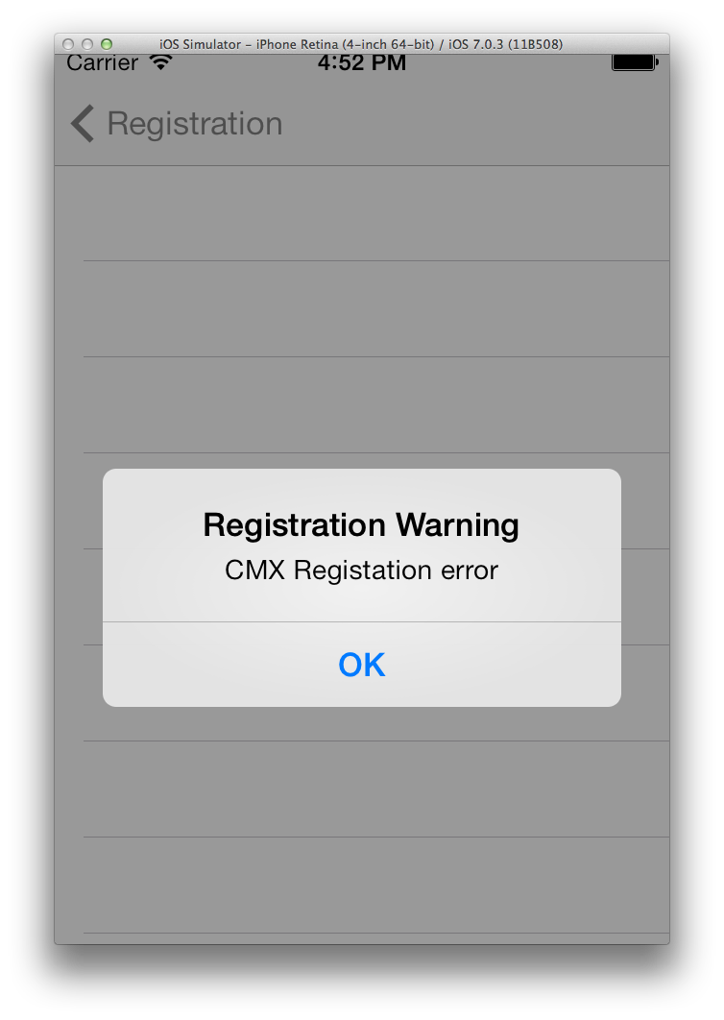

|  |  |
| --- | --- |
|  |  |

Else if the server is able to register the device we are going to fetch the X/Y Coordinates of the device and the deviceID using the APIs provided by the CISCO CMX SDK solution as shown in the figure below.

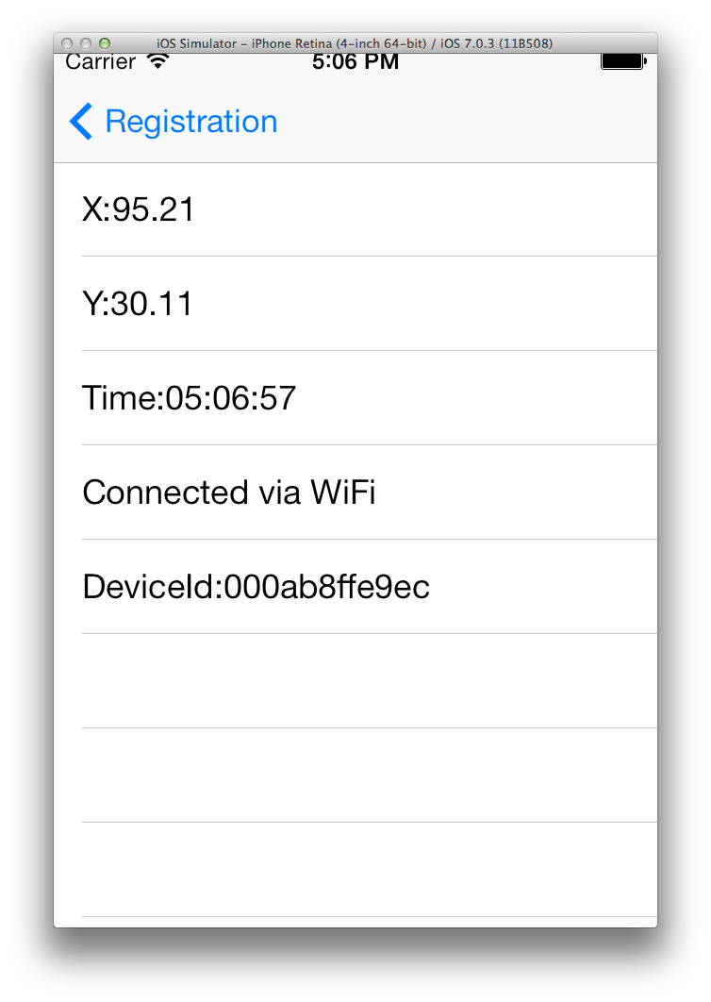

### Getting Started

This document assumes the developer has downloaded the CISCO CMX SDK and should have at least the following directories in their environment before getting started :

3rd Party Dependencies : AFNetworking, JASidePanels, Reachability and SMCalloutView.

CMX.framework which is the framework which powers our SDK solution.

It is also assumed the user has ios6 or ios7 and XCode version greater than 5.

Importing the framework

Open XCode v5 (or latest) and Select Create a New XCode Project.

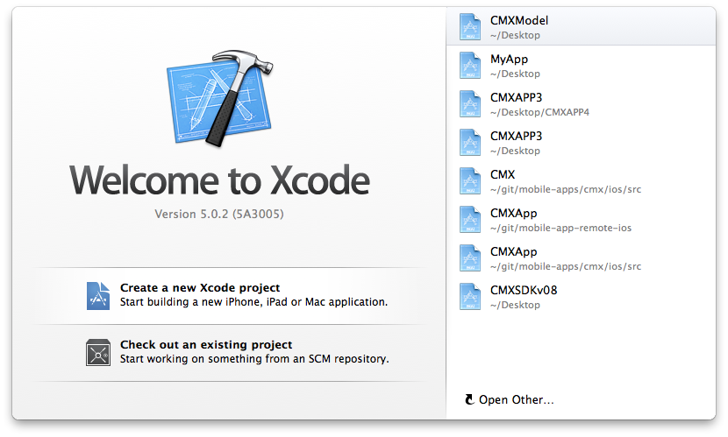

Select ***iOS Application -> Empty Application***.

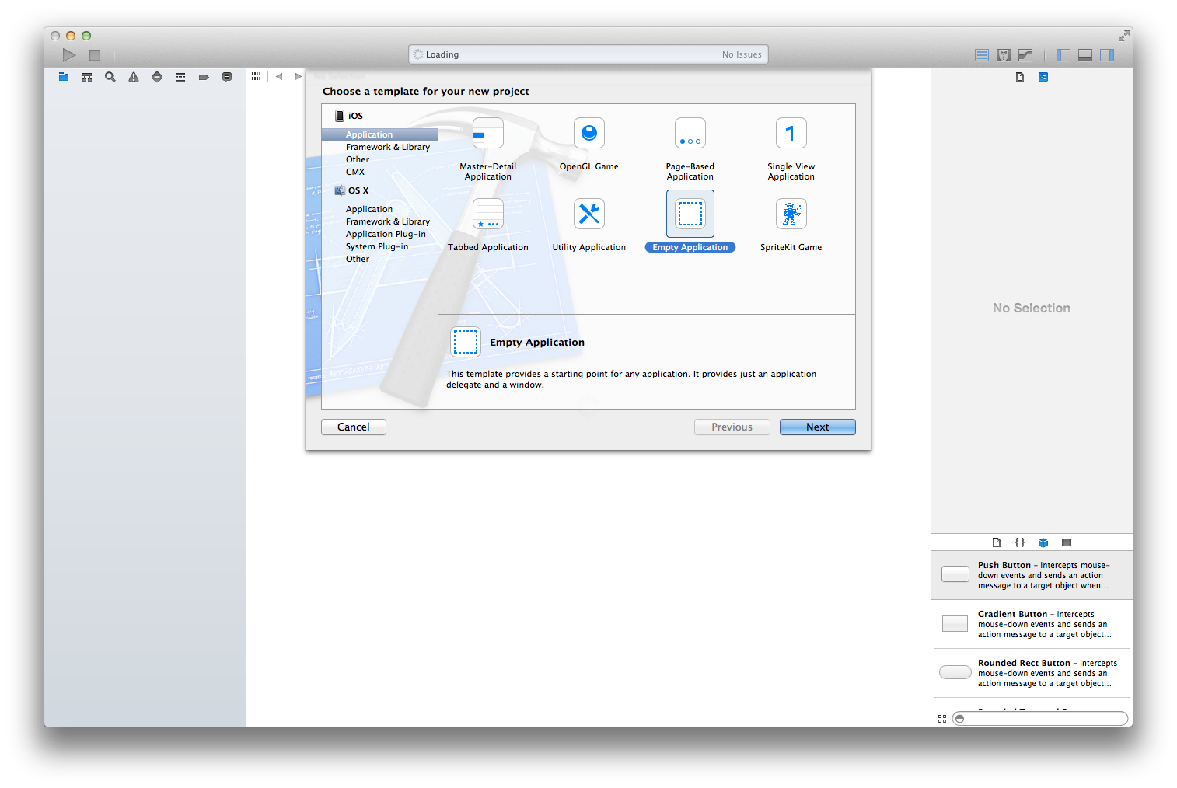

Add your product name and class prefix. You can unselect use Core Data for now. We will add it later.

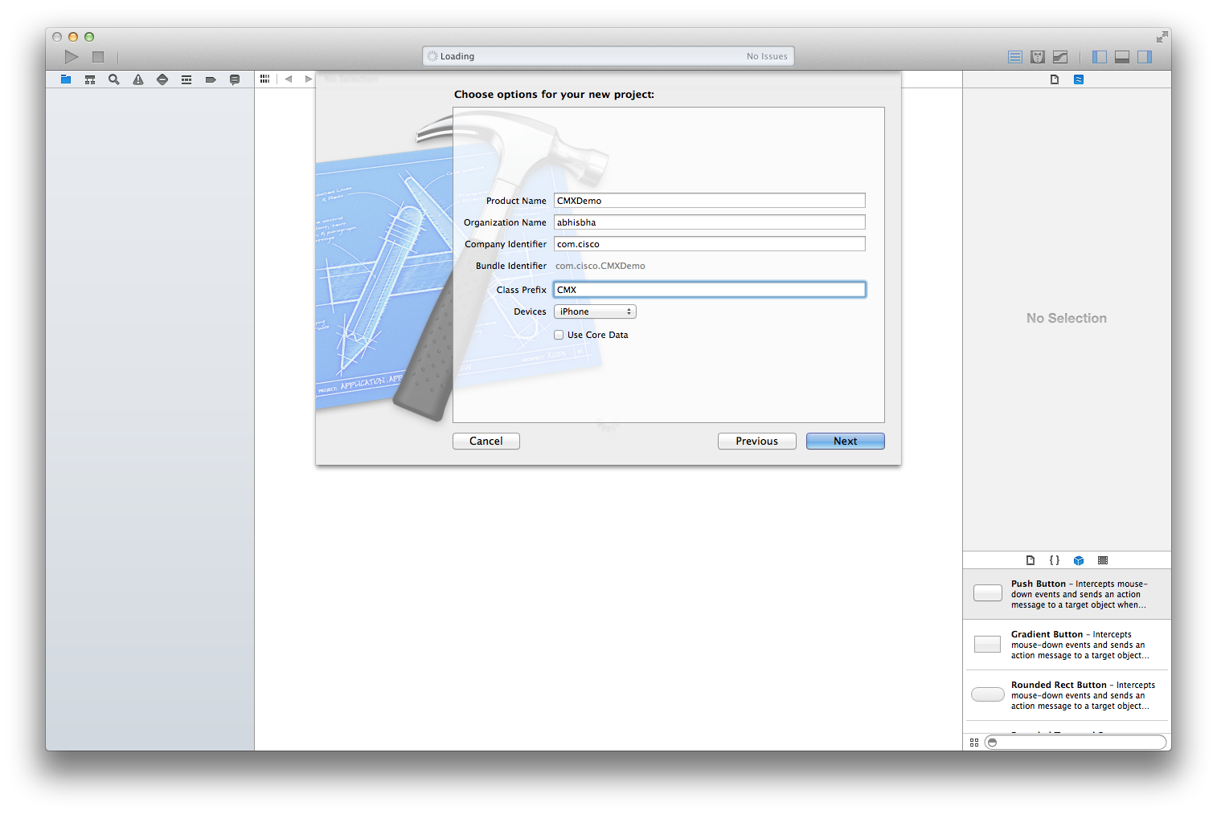

Select ***Next*** . Create a git repository for your project as prompted by Xcode. Now in XCode you will be able to see your development environment.

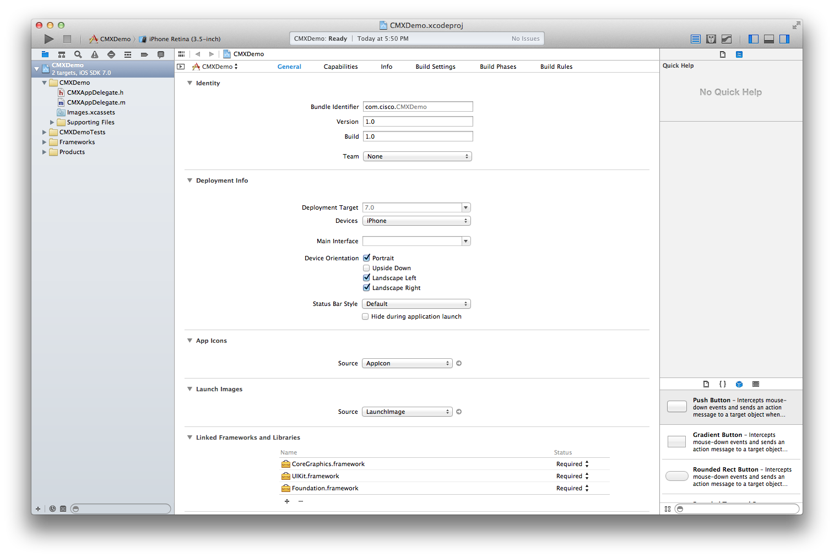

#### Adding the Framework and 3rd Party Dependencies

First we add the CMX.framework :



Click on the + sign in the General Tab under Linked Frameworks and Libraries.

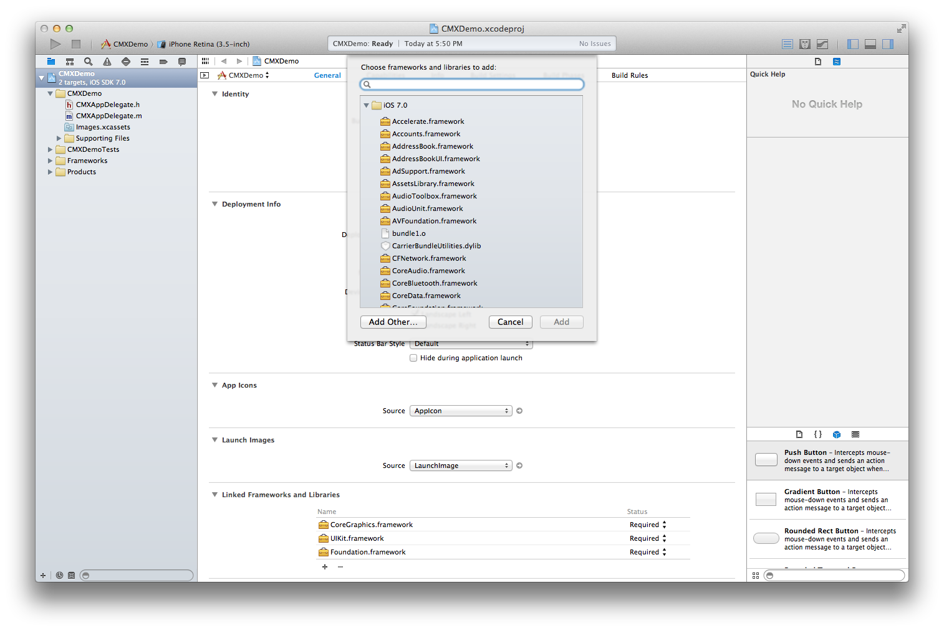

Select ***Add Other*** and browse to the CMX.framework under your CMX SDK and select open.

Once you do that you should see CMX.framework come up in the list of frameworks included in your project .

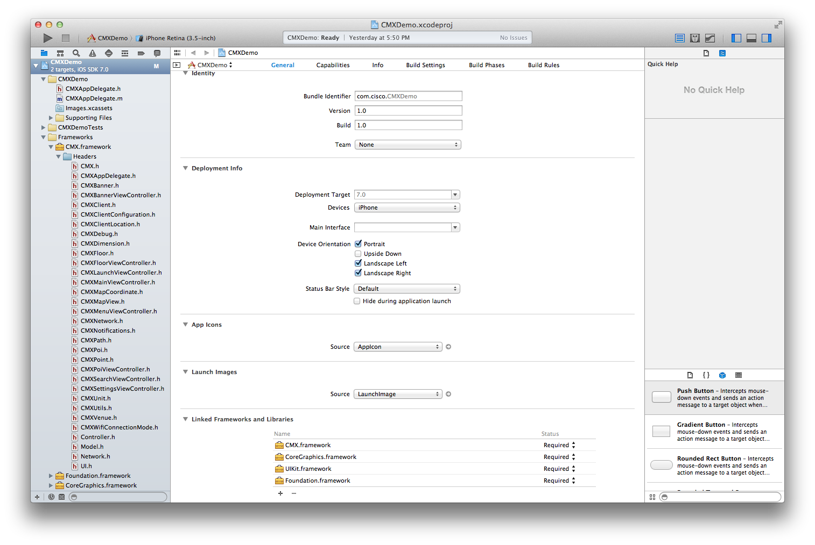

You should also be able a see a list of header files under the Headers folder in **CMX.framework**.

Now we are going to add 3rd party libraries to our project.

For adding the 3rd party libraries we are simply going to drag and drop the folders in our project. The third party libraries you need to place in your project are : AFNetworking, Reachability, SMCalloutView, JASidePanels.

When dragging and dropping the folders make sure you select ***« Create Groups for any added folders »*** and the target is selected as your appname.

At the end your project window should look like this :

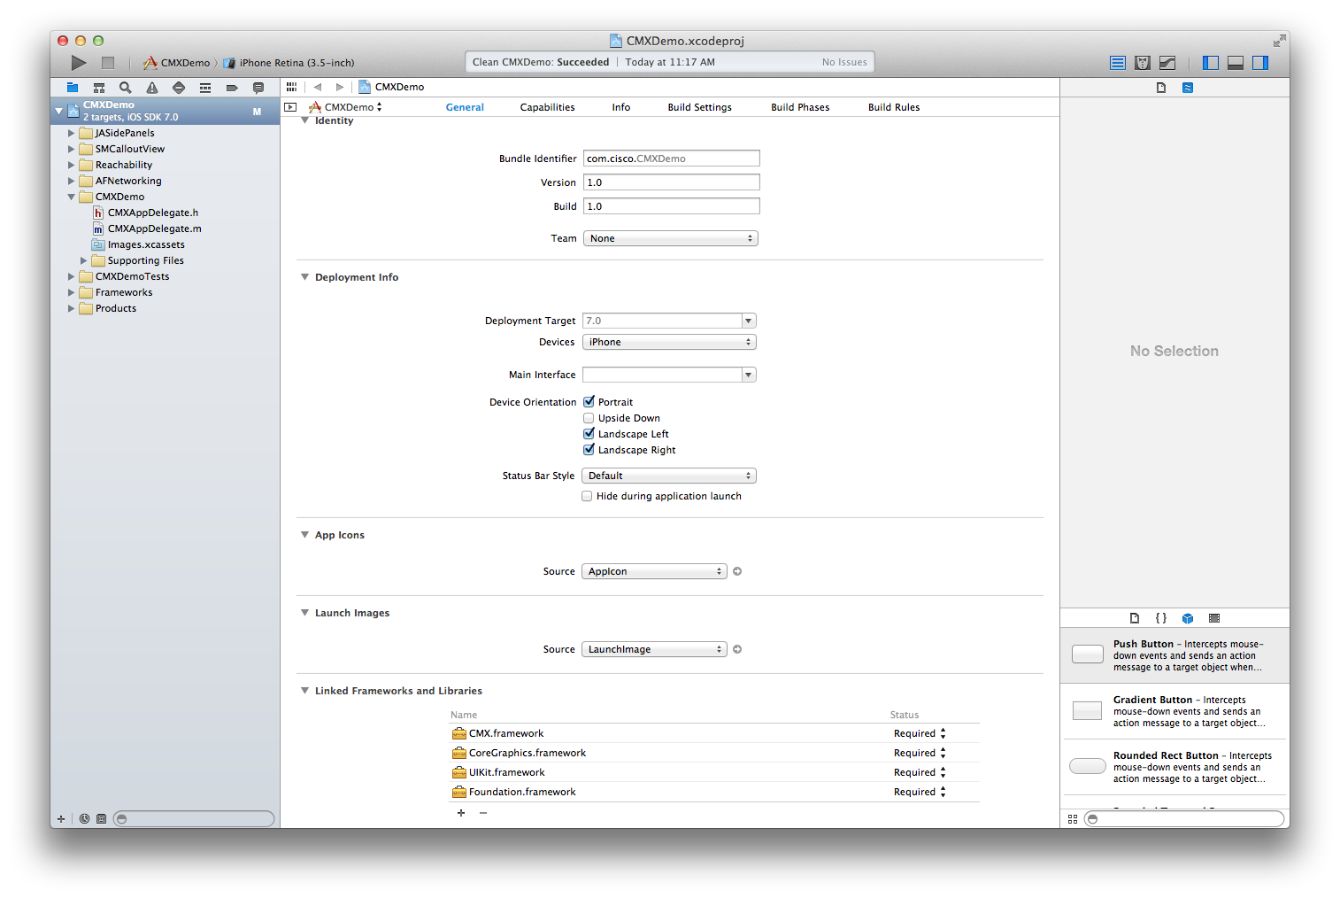

Creating the Storyboard

We are going to start with the view of our app by creating storyboards.

Creating storyboards can be learnt using Apple’s iOS developer manual.

The story board we are going to create will have a navigation controller, a view controller named as Registration View Controller and a Table View Controller with dynamic cells which we rename as Client Details View Controller.

The RegistrationViewController has a text field and a register button . Create a placeholder for them using the storyboard drag and drop feature in the CMXRegistrationViewController. This should create the following two properties in the CMXRegistrationViewController.m.

@interface CMXRegistrationViewController ()

@property (weak, nonatomic) IBOutlet UITextField *serverUrl;

@property (weak, nonatomic) IBOutlet UIButton *registerButton;

@end

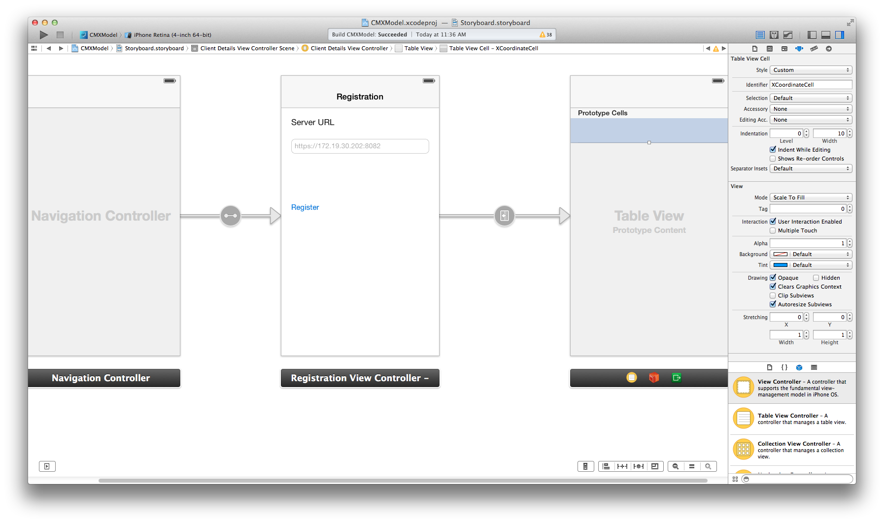

Once you have created the storyboard add a push segue from the Register button in the registration view controller to the table view controller. This ensures that when you click on the Register button the Client Details View Controller gets loaded. On the ClientDetailsViewController we add a cell and label the identifier as « XCoordinateCell »

#### Using the CMX SDK in your app

For using the CMX SDK in your mobile app, we shall be using the CMXRegistrationViewController and CMXClientDetailsViewController.

Before starting first in your appdelegate implementation (.m file) make sure that the didFinishLaunchingWithOptions method returns “YES” instead of a white screen it returns by default.

- (BOOL)application:(UIApplication *)application didFinishLaunchingWithOptions:(NSDictionary *)launchOptions

{

return YES;

}

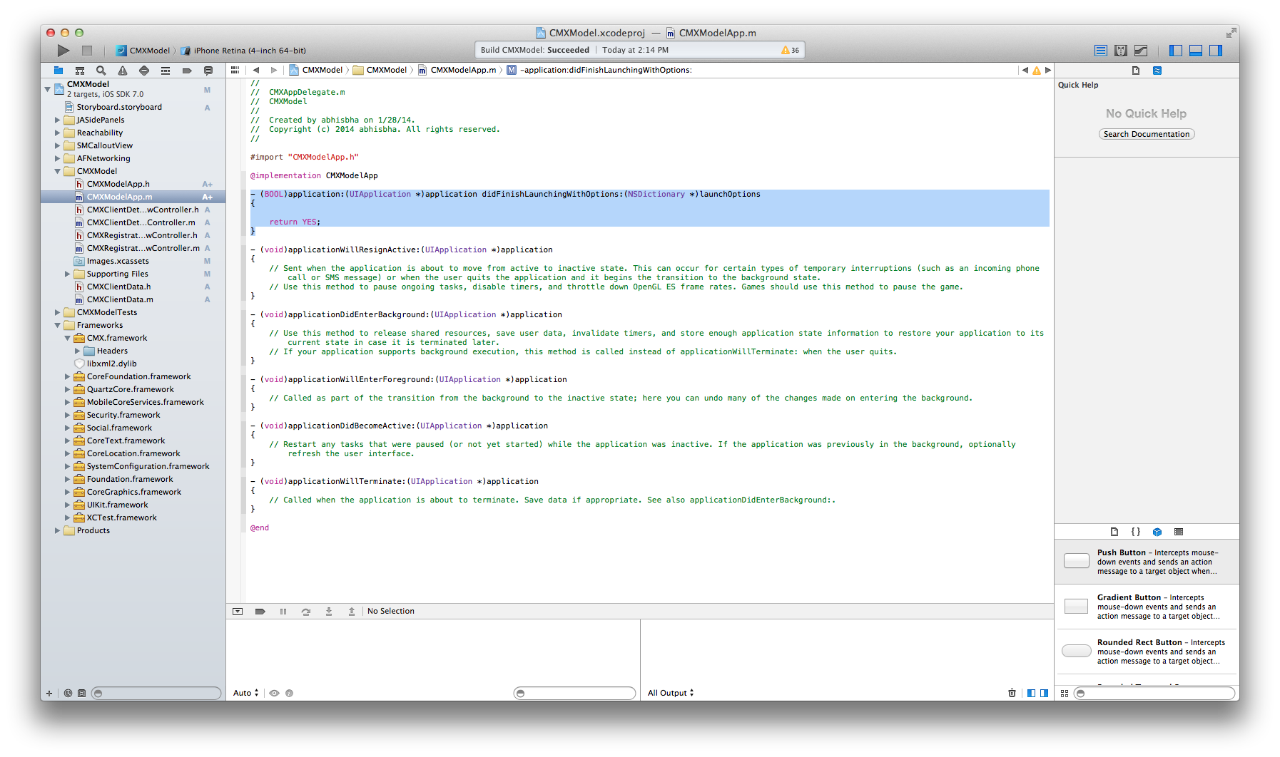

First we need to register the app using CMXRegistrationViewController.

Import the relevant declarations from CMX framework that we initially added.

#import <CMX/CMXClientConfiguration.h>

#import <CMX/CMXClient.h>

#import <CMX/CMXClientLocation.h>

#import <CMX/CMXMapCoordinate.h>

#import <CMX/CMXNetwork.h>

Whenever the register button is clicked on the Registration View Controller, the flow will come to the push segue’s prepareForSegue message.

In the prepareForSegue message, we are going to register the device using our registerForNetworks method in the SDK’s CMXClient.h.

-(void) registerForNetworks:(NSArray*)networks

completion:(void (^)())completion

failure:(FailureBlock)failure;

The registerForNetworks block takes an array of dictionaries (network’s ssid,password) as an input argument . We prepare a dummy dictionary in the following way for the purpose of the sample app. If needed we can also pass an empty dictionary. The purpose of the dictionary is to inform the CMX Mobile App Server of the available ssid’s on the venue.

NSDictionary *item = @{@"ssid" : @"alpha", @"password" : @"xyx"};

NSMutableArray* networks = [NSMutableArray array];

[networks addObject:[CMXNetwork modelObjectWithDictionary:item]];

We need to pass the registerForNetworks message block on a CMXClient instance. The CMXClient instance returns the shared instance of the CMX Client (behaves like a singleton class).

The CMX Client instance has associated configuration message where we can set the serverURL entered on the registration view controller. We first get the serverURL text from the property we defined as serverUrl.

-(CMXClientConfiguration*) configuration {

CMXClientConfiguration *config = [[CMXClientConfiguration alloc] init];

config.serverURL = [NSURL URLWithString:self.serverUrl.text];

return config;

}

Then we set this server url on the CMXClient instance :

CMXClientConfiguration* configuration = [self configuration];

[CMXClient instance].configuration = configuration;

We are now prepared to invoke the registerForNetworks on the CMXClient instance :

[[CMXClient instance] registerForNetworks:networks

completion:^() {

NSLog(@"Completed Registration");

}

failure:^(NSError* error) {

UIAlertView* alertView = [[UIAlertView alloc] initWithTitle: NSLocalizedString(@"Registration Warning", @"")

message: NSLocalizedString(@"CMX Registation error", @"")

delegate: self

cancelButtonTitle: nil

otherButtonTitles: NSLocalizedString(@"OK", @""), nil];

[alertView show];

}];

If the registration is complete we log successful completion and if it fails we show an alert box with a Registration error message.

Finally your prepareForSegue method should look something like this :

-(void)prepareForSegue:(UIStoryboardSegue *)segue sender:(id)sender{

if (sender == self.registerButton) {

CMXClientConfiguration* configuration = [self configuration];

[CMXClient instance].configuration = configuration;

NSDictionary *item = @{@"ssid" : @"alpha", @"password" : @"xyx"};

NSMutableArray* networks = [NSMutableArray array];

[networks addObject:[CMXNetwork modelObjectWithDictionary:item]];

[[CMXClient instance] registerForNetworks:networks

completion:^() {

NSLog(@"Completed Registration");

}

failure:^(NSError* error) {

UIAlertView* alertView = [[UIAlertView alloc] initWithTitle: NSLocalizedString(@"Registration Warning", @"")

message: NSLocalizedString(@"CMX Registation error", @"")

delegate: self

cancelButtonTitle: nil

otherButtonTitles: NSLocalizedString(@"OK", @""), nil];

[alertView show];

}];

}

}

Now if the registration is successful we need to get the location of the device from the CMX Mobile App Server. This we do in the CMXClientDetailsViewController.

We might want the mapCoordinates to be available to other classes as we delevlop our app [it is not essential for this app].

Hence in the CMXClientDetailsViewController.h we add a property :

@property (strong,nonatomic) CMXMapCoordinate *mapCoordinates;

Then we synthsize it in the .m file :

@synthesize mapCoordinates;

For this we import the following headers from our framework :

#import <CMX/CMXMapCoordinate.h>

#import <CMX/CMXClient.h>

#import <CMX/CMXClientLocation.h>

For getting the location we add the following method to the .m file:

-(void)loadUserLocation {

if ([[CMXClient instance]isRegistered]){

[[CMXClient instance] startUserLocationPollingWithInterval:5 update:^void(CMXClientLocation *clientLocation) {

self.mapCoordinates=clientLocation.mapCoordinate;

NSLog(@"Finished Loading User Location %F %F",mapCoordinates.x,mapCoordinates.y);

}];

}

}

We first check if the CMXClient instance is registered or not before making the location update calls. The method we use for location update is startUserLocationPollingWithInterval. It takes the number of seconds for location polling as its input. It returns the CMXClientLocation object and its mapCoordinate property holds the x,y coordinates for the device.

We call the loadUserLocation method from the viewDidLoad method :

- (void)viewDidLoad

{

[super viewDidLoad];

[self loadUserLocation];

}

Now all that is left is to populate the dynamic table cells with the data we have. For the purpose of simplicity we do it in the Controller itself using an array we call displayElements.

@interface CMXClientDetailsViewController ()

@property (strong,nonatomic) NSMutableArray *displayElements;

@end

Then we add a method to add the mapcoordinates to the array.

-(void)loadDisplayElements{

[self.displayElements removeAllObjects];

if (mapCoordinates !=nil){

[self.displayElements addObject:[NSNumber numberWithFloat:mapCoordinates.x]];

[self.displayElements addObject:[NSNumber numberWithFloat:mapCoordinates.y]];

}

}

We call the loadDisplayElements in our loadUserLocation :

[self loadDisplayElements];

The other thing we display is the deviceID for the Client :

-(NSData *) getDeviceId{

return[[NSUserDefaults standardUserDefaults] objectForKey:@"deviceId"];

}

Our final loadDisplayElements and loadUserLocation would look like this :

-(void)loadUserLocation {

if ([[CMXClient instance]isRegistered]){

[[CMXClient instance] startUserLocationPollingWithInterval:5 update:^void(CMXClientLocation *clientLocation) {

self.mapCoordinates=clientLocation.mapCoordinate;

[self loadDisplayElements];

[self.tableView reloadData];

}];

}

}

-(void)loadDisplayElements{

[self.displayElements removeAllObjects];

if (mapCoordinates !=nil){

NSLog(@"In Map Coordinates add");

[self.displayElements addObject:[NSNumber numberWithFloat:mapCoordinates.x]];

[self.displayElements addObject:[NSNumber numberWithFloat:mapCoordinates.y]];

}

NSData *deviceId=[self getDeviceId];

[self.displayElements addObject:deviceId];

}

Finally all we need is to populate the table cells :

- (NSInteger)numberOfSectionsInTableView:(UITableView *)tableView

{

// Return the number of sections.

return 1;

}

- (NSInteger)tableView:(UITableView *)tableView numberOfRowsInSection:(NSInteger)section

{

// Return the number of rows in the section.

return [self.displayElements count];

}

- (UITableViewCell *)tableView:(UITableView *)tableView cellForRowAtIndexPath:(NSIndexPath *)indexPath

{

static NSString *CellIdentifier = @"XCoordinateCell";

UITableViewCell *cell = [tableView dequeueReusableCellWithIdentifier:CellIdentifier forIndexPath:indexPath];

// Configure the cell...

switch (indexPath.row) {

case 0:

cell.textLabel.text = [NSString stringWithFormat:@"%@%@",@"X:",[self.displayElements objectAtIndex:indexPath.row]];

break;

case 1:

cell.textLabel.text = [NSString stringWithFormat:@"%@%@",@"Y:",[self.displayElements objectAtIndex:indexPath.row]];

break;

case 2:

cell.textLabel.text = [NSString stringWithFormat:@"%@%@",@"DeviceId:" ,[self.displayElements objectAtIndex:indexPath.row]];

break;

default:

cell.textLabel.text = [NSString stringWithFormat:@"%@",[self.displayElements objectAtIndex:indexPath.row]];

break;

}

return cell;

}

Now select your target device to iPhone Retina 4-inch 64 bit and start your build.



#### Configuring BLE Beacon on the SDK

A developer using the CMX iOS SDK can download the BLEBeacon List from the mobile app server on a per floor and a per venue basis: To download the BLEBeacons at a venue a developer has to use the following message in CMXClient.h:

loadBleBeaconsOfVenue:start:completion:failure

To download the BLEBeacons on a floor a developer has to use the following message in CMXClient.h:

loadBleBeaconsOfFloor:ofVenue:start:completion:failure

To start monitoring for beacons on a floor a developer can use the following message on CMXClient.h :

startBleBeaconMonitoringOfFloor:OfVenue:completion:Failure

To stop monitoring for beacons on a floor a developer can use the following message on CMXClient.h :

stopBleBeaconMonitoringOfFloor:OfVenue:completion:Failure

The developer needs to remember that BLE Beacon monitoring is done on a per floor basis. If the client changes floors, the developer needs to take care of starting beacon monitoring on the new floor.

If the iOS device does not support Beacon monitoring, the CMX iOS SDK will throw up the following alert box when the

startBleBeaconMonitoringOfFloor:OfVenue:completion:Failure message is invoked :

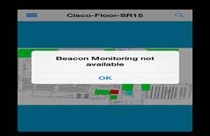

# Troubleshooting

## Location is not being updated until after some delay

The device location update is occurring very slowly. The updates were working well at one time but slowed over time.

* Navigate to the MSE UI: https://<MSE_IP>/mseui/
* Select **Settings** button on the home page
* Select the folder **Context Aware Service > Notifications > Statistics**
* The host address of the CMX Mobile App Server should be shown and status UP. If Down then the server is not being sent updates. Check network connectitity to server.

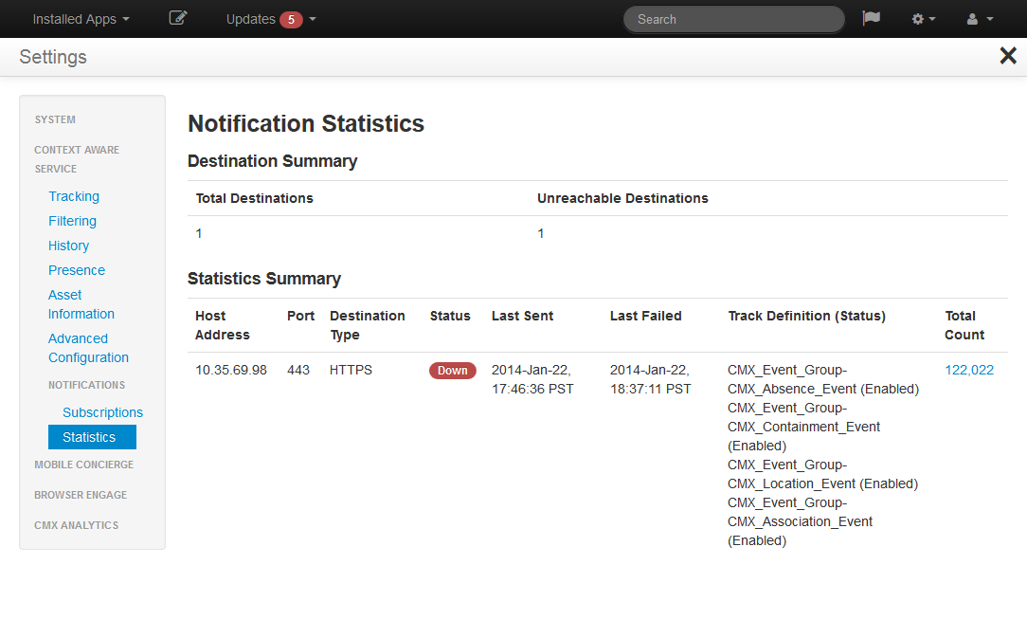

* Click on the total count link for the server to get more statistics
* Check the Current Queue Usage is not 100% or other high percentage

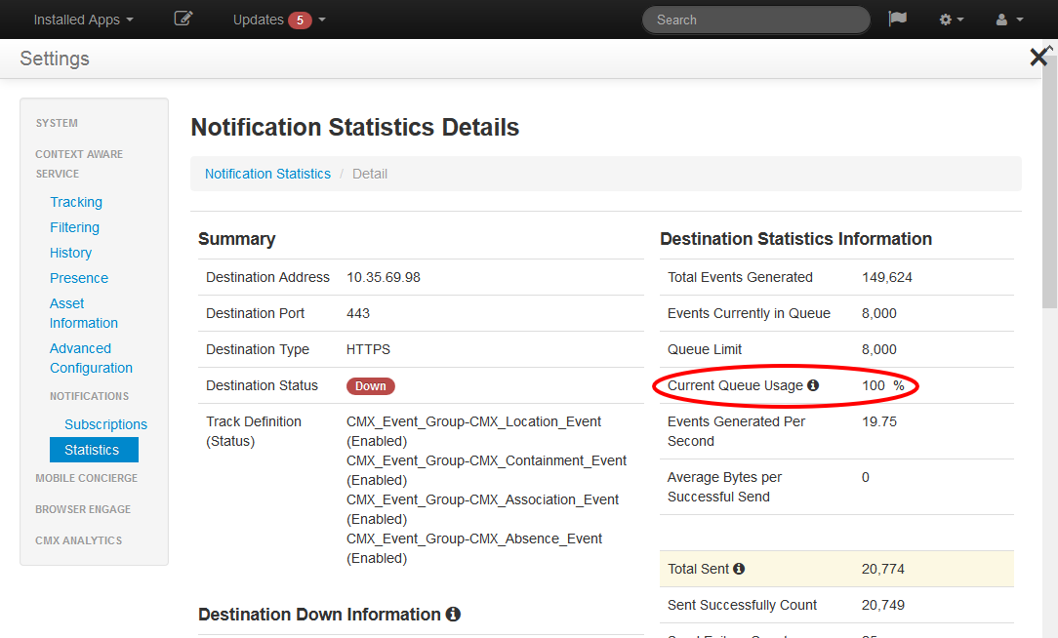

* If the queue usage is high then the license may not be adequate for the client count or the Queue size might need increasing.

## CMX Mobile folder is not visible

The CMX Mobile folder may not be visible if the MSE was upgraded from a previous release. This will be due to the role not having the operation added.

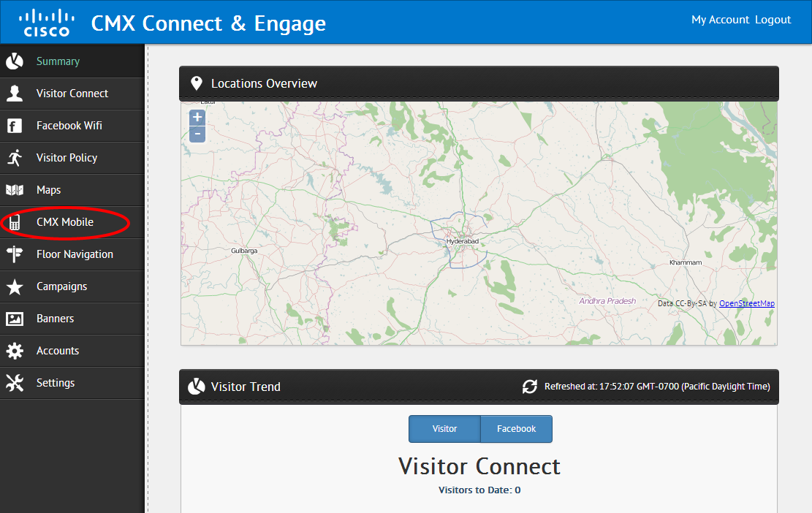

Select the folder **Settings > Roles** to view the current role settings.

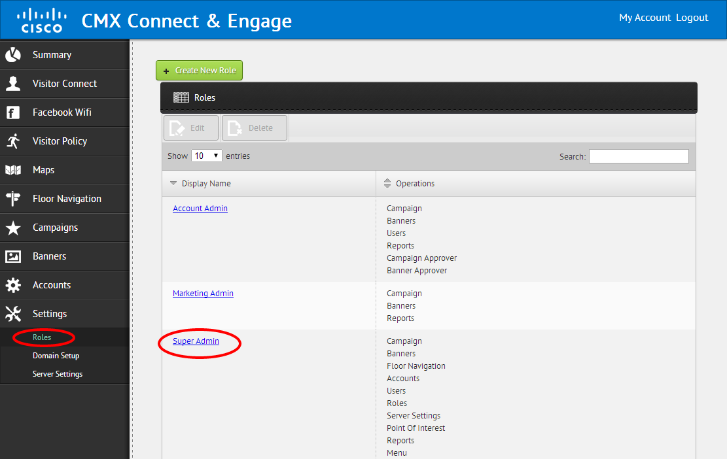

Click the user to allow access to the role. The default *Super Admin* user can be changed by clicking the **Display Name**. Then in the dialog box add the **CMX Mobile** operation. After saving a browser refresh of the page will update and show the folder if the current logged in user has the assigned role.

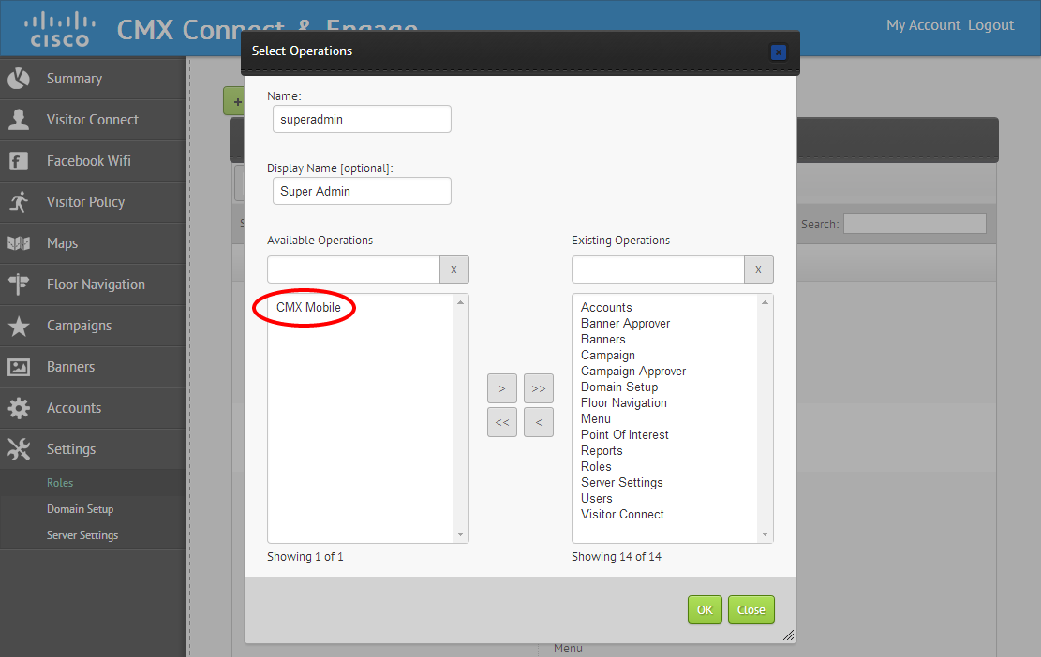

## How do we enable TRACE on the Mobile App Aerver

To enable trace logging,

Go to **/opt/cmx-mobile-app-server/setup**. Run the **setup.sh** script. Select Log Level and set it to trace.

To enable trace messages on the debug command tools in the bin directory, edit **/opt/cmx-mobile-app-server/apache-tomcat/webapps/cmx-cloud-server/WEB-INF/classes/cli/cliLogback.xml**

and set level to **trace**.

## iOS 7 registration with the Mobile App Server is failing

Make sure you can register your device with the mobile app server simulator.

From iOS7 onwards apple does not allow applications to access the MAC address of the iOS device. We work around that issue using the MAC address the device uses to join the network through the access point.

In order to do that your device needs to be connected to the SSID on the venue which is being managed by your MSE. Only then will you be able to register your iOS 7 device.

From your application you need to send the push notification registration id and the preferred networks through the registration method.

If the registration does not work even if you are connected to the SSID on the venue, you need to check the Mobile App Server logs.

Go **to /opt/cmx-mobile-app-server/logs**/. Do

***tail –f cmx-mobile-app-server.log | grep –i registration***

You should see a message like this :

*Client registration requested with registration ID '<64 byte number>' AP MAC Address ‘<mac>’ Client IP Address '<ip>' Client Type 'ios' Client MAC Address 'None'*

Make sure you have a push notification registration id which will be a 64 byte number. Make sure the client ip and the ap mac address are there. Except these three information pieces ios7 registration will not work.

If the Mobile App Server successfully registered you, you should see a message like this:

*Device registration has completed successfully*. Respond with registration completion message if the Mobile App Server is unable to detect you on the venue you should see a message like : *No Pending Association Event found*.

In that case make sure the Mobile App Server received the association event for your device. Note the macaddress of your device (*Settings>General>About*). Go to the cmx-mobile-app-server.log and search for the macaddress for your device. Make sure you have an association event for the device if trace is enabled on your logs.

*Completed update of assocation event for client '<mac>'. Respond object is {"configuration":{"notifications_enabled":"true","update_distance":1,"zone_timeout":0,"subscription_name":"CMX_Location_Event","mac_address_list":["<mac>"]}}*

## iOS push notification is not working

iOS Push Notification is a three way communication. When the client changes a zone and the new zone has a push notification configured on it, the Mobile App Server will send the notification to the APNS server and then the APNS server will trigger a notification to the registered device.

1. Check the provisioning profile in your application has the device UDIDs for the device on which you installed the application. Also make sure that you have enabled notifications in the settings>notification center for the application.
2. Make sure in your application delegate you have implemented these 3 methods:

* *registerForRemoteNotificationTypes:*
* *application:didRegisterForRemoteNotificationsWithDeviceToken:*
* *application:didFailToRegisterForRemoteNotificationsWithError:.*

Make sure you do not get any error in the *application:didFailToRegisterForRemoteNotificationsWithError:*

1. Make sure your iOS device can access the internet.
2. Apple sends push notifications over both cellular data and WiFi. Make sure the ports 2195 and 2196 on the Mobile App Server can reach the apple push notification server (inbound and outbound). Additionally make sure the device can reach the Apple push Notification Server on port 5223 (inbound and outbound).

On the mobile app server you can do:

***telnet gateway.push.apple.com 2195***

On the iOS device you can download and application like iTelnet

and then telnet to port **5223** on **1-courier.push.apple.com**.

1. Try to manually send a push notification from the mobile app server. Use the sendPushNotificationByMac.sh script under /opt/cmx-mobile-app-server/bin . Example :

***./sendPushNotificationByMac.sh <macaddressOfTestDevice> “Test Message”***

Also try the script

***./testPushNotificationByMac.sh <macaddressOfTestDevice>***

6. Make sure the .p12 file you uploaded in the Connect and Engage push notification configuration is the correct p12 file under : /opt/cmx-mobile-app-server/images. Delete other p12 files if they are there under /opt/cmx-mobile-app-server/images.

7. If you are still unable to get push notifications, try to use a 3rd party service to send push notifications to your device.

An example would be this:

Install Houston on OSX :

Do ***sudo gem install houston***. If it fails run this command :

***sudo ARCHFLAGS=-Wno-error=unused-command-line-argument-hard-error-in-future gem install houston***

Generate a pem file from the p12 file using the following command :

***openssl pkcs12 -in Certificates.p12 -out apns-dev-cert.pem -nodes -clcerts***

The apns-dev-cert.pem will be the file to use to send push notifications :

Do :

***apn push "push notification token of device" -c /path/to /apns-dev-cert2.pem -m "Hello"***

If this method can send push notifications to your device then you can focus on the mobile app server – APNS server communication for debugging.

## Android Push notification is not working

1. Make sure your Android device can access the Internet.
2. Make sure the ports 5228, 5229, and 5230 are not blocked by firewalls.
3. Try to manually send a push notification from the mobile app server. Use the sendPushNotificationByMac.sh script under /opt/cmx-mobile-app-server/bin . Example :

***./sendPushNotificationByMac.sh <macaddressOfTestDevice> “Test Message”***

## No push notifications when I move are received but are when sent manually

The Mobile App Server sends push notifications everytime a client changes its position from one zone to another provided the new zone he moves into has a notification configured. However, once a client receives a push notification we prevent the app server to send push notification to the client again on the same zone within a certain period of time. By default this time period is set to 60 minutes.

If you want the Mobile App Server to send push notifications everytime a client enters a zone with a notification , you need to :

edit /**opt/cmx-mobile-app-server/apache-tomcat/webapps/cmx-cloud-server/WEB-INF/classes/config/settings.properties**

Then change the ***location.minutesBetweenSendingNotification*** parameter to 0.

Even after that you cannot see push notification on the client when it changes a zone, make sure that the client actually changes a zone and the zone change is reflected in the Mobile App Server.

For this :

Go to /opt/cmx-mobile-app-server/bin . Run the ***getLocationByMac.sh*** or ***monitorLocationByMac.sh*** the with the Macaddress of the client device as the parameter.

[ INFO] 2014-05-05 16:11:59,332 - ------- Wireless Client Location -------

[ INFO] 2014-05-05 16:11:59,339 - Last Updated Time: 5/5/14 4:10 PM

[ INFO] 2014-05-05 16:11:59,339 - MAC Address: 3c:d0:f8:08:c3:d3

[ INFO] 2014-05-05 16:11:59,339 - Device Type: ios

[ INFO] 2014-05-05 16:11:59,340 - Venue ID: AIR-MSE-VA-K9:V01:jkp-msevm.cisco.com_e3609d9c-04e8-11e3-b9d2-000c29084471:730297895206518936

[ INFO] 2014-05-05 16:11:59,340 - Floor ID: 730297895206518939

[ INFO] 2014-05-05 16:11:59,340 - Zone ID: 1654

[ INFO] 2014-05-05 16:11:59,340 - X: 83.48412

[ INFO] 2014-05-05 16:11:59,340 - Y: 21.228664

[ INFO] 2014-05-05 16:11:59,340 - Latitude: 37.4070027136576

[ INFO] 2014-05-05 16:11:59,340 - Longitude: -121.9290557956652

Make sure the zone Id of the client device actually changes when the devices moves from one zone to the other where a push notification is configured.

Lastly if the client does show a zone change make sure that in the /opt/cmx-mobile-app-server/logs/cmx-mobile-app-server.log the push notification is fired and no error is logged .

Starting to send push notification to client: <macaddress> with message: “Test Message”

## Getting push notifications with no message

Make sure you have configured the message on the zone correctly in Connect and Engage.

In the /opt/cmx-mobile-app-server/logs/cmx-mobile-app-server.log make sure the message you configured on the zone is received. Search with your message name in the log file. You should see something like :

*pushNotificationMessage= Value : “Your message”*

## I cannot get preferred networks on my device

Make sure on the MSEUI page on your MSE (https://<mseip>/mseui/) you have populated the Preferred Network field at the bottom of the page and synced it properly.

## I am not getting any latitude and longitude on my client

Ensure on the PI Maps page you have at least 3 GPS markers placed. Then save the page and sync the changes (or wait for the sync to happen).

On the Mobile App Server, go to /opt/cmx-mobile-app-server/logs and check if you receive the latitude and longitude values with the client movement event.

You can also go to /opt/cmx-mobile-app-server/bin and run the *getLocationByMac* script with a client macaddress as argument and check if you receive the latitude and the longitude for the client.

## None of the steps resolved my issue

Go to /opt/cmx-mobile-app-server/bin. Run the ***collectDebugInfo.sh*** script. Send the generated file to technical support.

# Known Issues